# Company Profile

**The One Technologies**

The One Technologies is India’s top-leading and fast-growing web and mobile app development company located in Ahmedabad which has emerged as a leading inventor, innovator and implementer of cutting-edge technology. Incepted in the year of 2010 at Ahmedabad, we have emerged as a top web and mobile app development company with an aim to provide quality services in the web, mobile and custom software development solutions. We work to fulfil the requirements of the clients in the area of Web Hosting, Web Development, Mobile App Development, Search Engine Optimization (SEO) Service, E-commerce Solution, Internet Marketing, Online Branding, and Enterprise Solutions.

# Project Profile

* 1. **Project Definition:**

CrackBook Mobile App

* 1. **Project Description:**

CrackBook is an Android Based Mobile application. It provides complete information to the users on government exams. It provides current affairs, all the details about exams, how to prepare, who are eligible for any particular exams, how to apply for the exams, what is syllabus, etc. In the application users can check their knowledge or preparation via short practice test. In this application we are providing old questions paper for more references. App has one feature, where user can request for any particular topic or article about general knowledge if needed. We are also allowing user to download pdf for offline reading or preparations.

* 1. **Existing System:**

There are many applications and websites that provides all this materials and other guidance for preparations of government and competitive exams. For more access users have to pay some money or users have to purchase subscription. We are providing all this material and guidance without paying single money, it is fully free to access. One more feature of requesting for any materials is also new, it is not providing by any other website, system or applications.

* 1. **Problem Statements:**
* There are many applications and websites, they are providing all this. But for that users have to pay some money.
* In old system or applications does not have any feature for users, where user can request for any paper or articles.
* This is an improved application and it was easy to use, attractive and more reliable.
  1. **Need for New System:**

After using some level of old system, user need to purchase or pay some amount to get access of more materials. When we are providing all this free of cost. And we are also providing one feature where user can request of any particular material that they want.

* 1. **Proposed System:**
* Our proposed application gives all the latest news about exams and guidelines for preparing any exams.
* We are providing practice test features also.
* Along with this we are also providing current affairs, tips and tricks for easy preparations.
  1. **Scope:**
* It is developed for effective and easy preparations of competitive exams.
* Users can solve the doubts.
* Users can get updates for recruitments opening and hiring process.
* Videos for prepare and improve interviews.
  1. **Outcomes:**
* Users can access this application from anywhere in the world but only available for Indian governments exams preparations.
* It is android application so user can access or prepare for exam at anywhere and anytime.
  1. **Tools & Technologies:**

1. **Tools:**
2. Android Studio
3. Firebase Real-time Database
4. Android Mobile Phone/Android Virtual Device
5. **Technologies:**
6. Front End:

* Java:

Java is a general proposed programming language developed by Sun Microsystems to create web application, Mobile application, Desktop GUI application etc. It works on a different platform and it is easy to learn and use. It is totally object-oriented language.

1. Back End:

* Firebase Real-time Database:

Firebase Real-time Database is free online Real-time Database system. It is widely famous and most used database for mobile computing like Android, iOS, Blackberry, etc. It is free of cost to use for small projects.

* 1. **Project Plane:**

|  |  |  |  |  |
| --- | --- | --- | --- | --- |
| **Sr. No** | **Milestone** | **Start Date** | **End Date** | **Duration** |
| 1 | Project Profile | 01/12/2020 | 05/12/2020 | 5 Days |
| 2 | Requirement Analysis | 08/12/2020 | 19/12/2020 | 12 Days |
| 3 | Design | 22/12/2020 | 02/01/2021 | 12 Days |
| 4 | Implementation | 05/01/2021 | 27/02/2021 | 53 Days |
| 5 | Testing | 02/03/2021 | 06/03/2021 | 5 Days |
| 6 | Future Enhancement | 09/03/2021 | 11/03/2021 | 3 Days |
| 7 | Bibliography | 12/03/2021 | 13/03/2021 | 2 Days |

**Table 1: Project Plane**

**TimeLine Chart**



**Figure 1: TimeLine Chart for Project Plane**

# Requirement Analysis

# 3.1 Feasibility Study:

As the name implies, a feasibility study is used to determine the viability of an idea, such as ensuring a project is legally and technically feasible as well as economically justifiable. It tells us whether a project is worth the investment—in some cases, a project may not be doable. There can be many reasons for this, including requiring too many resources, which not only prevents those resources from performing other tasks but also may cost more than an organization would earn back by taking on a project that isn’t profitable.

## There are different types of feasibility study.

1. **Technical Feasibility:**

This study focuses on the technical resources available in application. This app is built on android platform which is worldwide use standard. Therefore, the technical risk is not so high and hence it is feasible. Users require only smart phone and internet connectivity to use this app.

1. **Economical Feasibility:**

This application is free of cost for the users to use they don’t need to purchase application from anywhere. The system will follow the freeware software standard. Other than this in the application, users have don’t need to pay any single rupees for taking any helps.

1. **Operational Feasibility:**

This study analyses how a project plan satisfies the requirements in the requirement phase of the development. The current mode of operation provides adequate throughput and response time. The system offers effective controls to protect against fraud and to guarantee accuracy and security of data and information. This application helps students or user to get access of all the materials easily.

* 1. **Users of the System:**
* There are two types of users of the system.

1. **Admin:**

* Admin can login to the system.
* After login to the system, admin can add, modify and update the materials in the system.
* Admin can also add new practice test and modify the test.
* Government exams guidelines and tips are also added by admin.

1. **Users:**

* Users can login/register into the system and access all the materials.
* Users can also can give practice test for more experience.
* They can download pdf file of any particular materials, articles or magazines.
* Users can request to the admin for any particular materials or articles.
  1. **Modules:**

1. **Test Management:**

* This module covers all the practice test and modify them.

1. **Articles Management:**

* This module manages all the articles and material in the system.
* Old questions papers of the exams are also handled in this.

1. **Tips & Guidelines Management:**

* This module manages all the information exams, tips and rules of particular exams.

1. **Report:**

* This module generates reports of all the user who have requested for materials. Which materials are more downloaded?
  1. **Process Model:**

**Spiral Model**

* Spiral Model is a combination of a waterfall model and iterative model. Each phase in spiral model begins with a design goal and ends with the client reviewing the progress.



**Figure 2. Spiral Model**

* **Why Spiral Model is used?**

Project is large.

Risk and cost evaluation are important.

Requirements are unclear and complex.

Changes may require at any time.

Significant changes are expected in the product during the development cycle.

* 1. **Hardware & Software Requirements:**
  2. **Server/Developer Side:**

1. **Software Requirement:**

* Front-End: Android Studio with Java JDK
* Emulator: Genny-Motion or Inbuilt Emulator
* Back-End: Firebase Online Database

1. **Hardware Requirement:**

* RAM: 8GB
* SSD/HHD: 120GB Or Above
* Operating System: Windows 7 Or Above (32 or 64)
* Screen Resolution: 1280*800 screen resolution
  1. **User/Client Side:**

1. **Software Requirement:**

* Android Version: 4.0(Ice Cream Sandwich) Or Above
* Google Play Version: 7.5 Or Above

1. **Hardware Requirement:**

* Device (Operating System): Android Device
* RAM: 512MB or Above
* Storage: 100MB or Above
  1. **Use Cases:**

1. **Admin:**

* **Actions:**

1. Login
2. Manage Materials
3. Manage Requests
4. Manage Practice Test/Exam
5. Manage Tips & Guidelines
6. **Users:**

* **Actions:**

1. Login/Register
2. View Materials, Articles, Books, Current Affairs
3. Give Practice Test/Exams
4. Make Request
5. View Guidelines/Tips
   1. **Use Cases:**

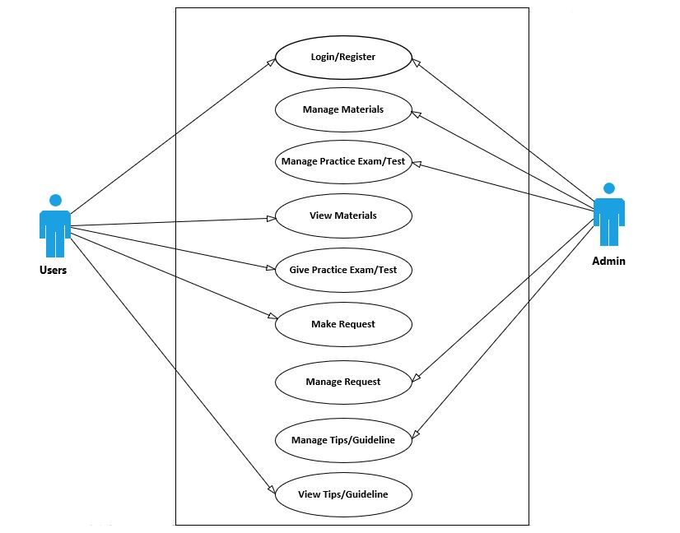

**Figure 3. Combine Use Case Diagram**

1. **Admin**

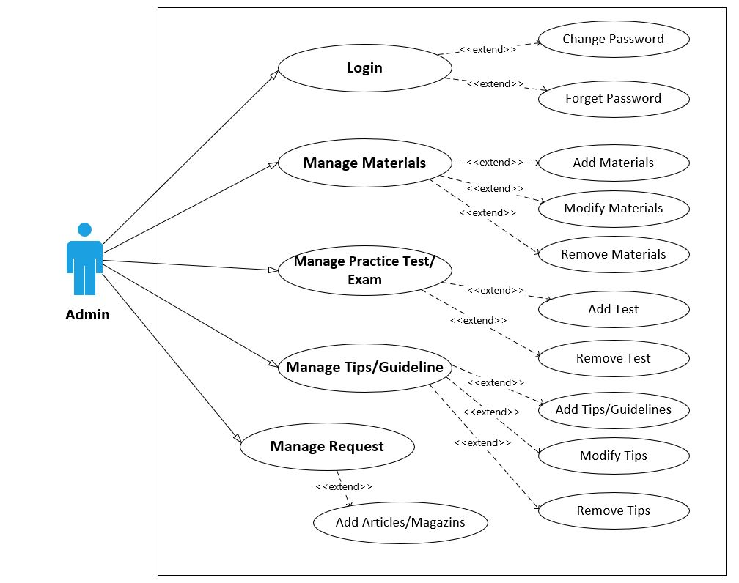

**Figure 4. Admin Use Case**

1. **User:**

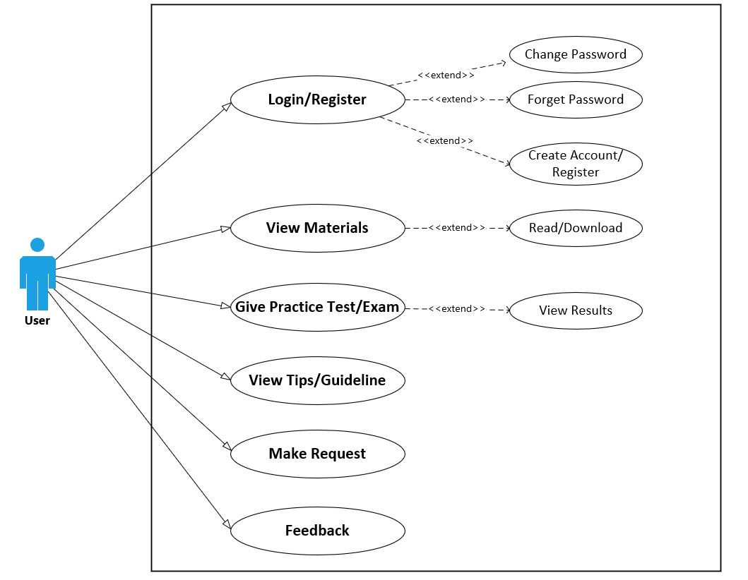

**Figure 5. User Use Case Diagram**

# Design

1. **Use Case Scenarios:**
2. **Admin Login:**

|  |  |
| --- | --- |
| Use case ID | UC01 |
| Use Case Name | Login |
| Primary Actor | Admin |
| Pre-Condition | Admin must have been registered. |
| Basic Flow of System | The application can be accessed through mobile number and password. |
| Alternative Way | There is no alternative way for login. |

**Table 2. Use Case Scenario for Admin Login**

1. **Manage Materials:**

|  |  |
| --- | --- |
| Use case ID | UC02 |
| Use Case Name | Manage Materials |
| Primary Actor | Admin |
| Pre-Condition | Admin must be logged in. |
| Basic Flow of System | Admin Can Add, Modify or Remove (Delete) any particular Material. |
| Alternative Way | There is no alternative way for managing Materials. |

**Table 3: Use Case Scenario for Manage Material**

1. **Manage Practice Exam/Test:**

|  |  |
| --- | --- |
| Use case ID | UC03 |
| Use Case Name | Manage Practice Exam/Test |
| Primary Actor | Admin |
| Pre-Condition | Admin must be logged in. |
| Basic Flow of System | Admin Can Add, Modify or Remove (Delete) any particular Practice Exam/Test. |
| Alternative Way | There is no alternative way for managing practice exam/test. |

**Table 4: Use Case Scenario for Manage Practice Exam/Test**

1. **Manage Request:**

|  |  |
| --- | --- |
| Use case ID | UC04 |
| Use Case Name | Manage User’s Request of Materials/Papers |
| Primary Actor | Admin |
| Pre-Condition | Admin must be logged in. |
| Basic Flow of System | Admin can add requested materials, paper or article in the system. |
| Alternative Way | There is no alternative way for managing user’s request. |

**Table 5: Use Case Scenario for Manage Request**

1. **Manage Tips/Guidelines:**

|  |  |
| --- | --- |
| Use case ID | UC05 |
| Use Case Name | Manage Tips/Guidelines |
| Primary Actor | Admin |
| Pre-Condition | Admin must be logged in. |
| Basic Flow of System | Admin can manage required and updated rules, tips and guidelines of exams. |
| Alternative Way | There is no alternative way for managing user’s request. |

**Table 6: Use Case Scenario for Manage Tips/Guidelines**

1. **User’s Login:**

|  |  |
| --- | --- |
| Use case ID | UC06 |
| Use Case Name | User’s Login |
| Primary Actor | Users |
| Pre-Condition | Users must be registered. |
| Basic Flow of System | The application can be accessed through mobile number/email and password. |
| Alternative Way | There is no alternative way for managing user’s request. |

**Table 7: Use Case Scenario for User’s Login**

1. **View/Download Materials:**

|  |  |
| --- | --- |
| Use case ID | UC07 |
| Use Case Name | View /Download Materials |
| Primary Actor | Users |
| Pre-Condition | Users must be logged in. |
| Basic Flow of System | Users can view all the materials and download. |
| Alternative Way | There is no alternative way for managing user’s request. |

**Table 8: Use Case Scenario for View/Download Materials**

1. **Give Practice Exam/Test:**

|  |  |
| --- | --- |
| Use case ID | UC08 |
| Use Case Name | Give Practice Exam/Test |
| Primary Actor | Users |
| Pre-Condition | Users must be Logged in.. |
| Basic Flow of System | Users can give practice exam/test and can evaluate themselves. |
| Alternative Way | There is no alternative way for managing user’s request. |

**Table 9: Use Case Scenario for Practice Exam/Test**

1. **Make Request:**

|  |  |
| --- | --- |
| Use case ID | UC09 |
| Use Case Name | Make Request |
| Primary Actor | Users |
| Pre-Condition | Users must be logged in. |
| Basic Flow of System | Users can request to the admin for any particular paper, article, magazines, etc. |
| Alternative Way | There is no alternative way for managing user’s request. |

**Table 10: Use Case Scenario for Make Request**

1. **View Tips/Guidelines:**

|  |  |
| --- | --- |
| Use case ID | UC10 |
| Use Case Name | View Tips/Guidelines |
| Primary Actor | Users |
| Pre-Condition | Users must be logged in. |
| Basic Flow of System | Users can view tips and tricks to crack the particular exam. They can also view all the guidelines of exams. |
| Alternative Way | There is no alternative way for managing user’s request. |

**Table 11: Use Case Scenario for View Tips/Guidelines**

1. **Forgot Password:**

|  |  |
| --- | --- |
| Use case ID | UC11 |
| Use Case Name | Forgot Password |
| Primary Actor | Admin, Users |
| Pre-Condition | They must be registered in system. |
| Basic Flow of System | They can forget their password through mobile number. |
| Alternative Way | There is no alternative way for forgot password. |

**Table 12: Use Case Scenario for Forgot Password**

1. **Change Password:**

|  |  |
| --- | --- |
| Use case ID | UC12 |
| Use Case Name | Forgot Password |
| Primary Actor | Admin, Users |
| Pre-Condition | They must be registered in system. |
| Basic Flow of System | They can change their password through old password |
| Alternative Way | There is no alternative way for forgot password. |

**Table 13: Use Case Scenario for Change Password**

1. **UML Diagrams:**

# Class Diagram:

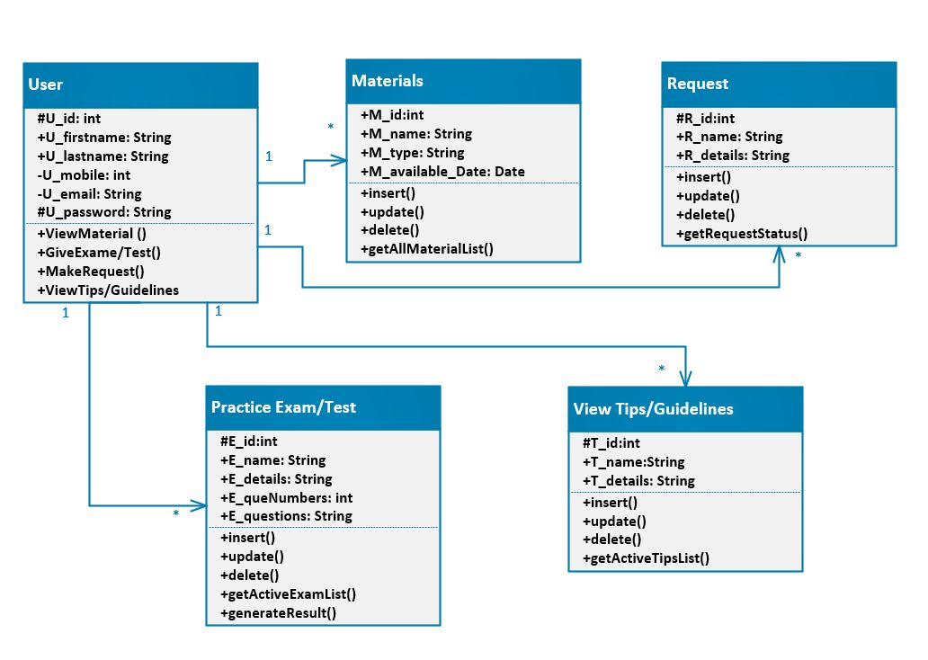

**Figure 6: Class Diagram for CrackBook**

# Sequence Diagram:

1. **Admin:**

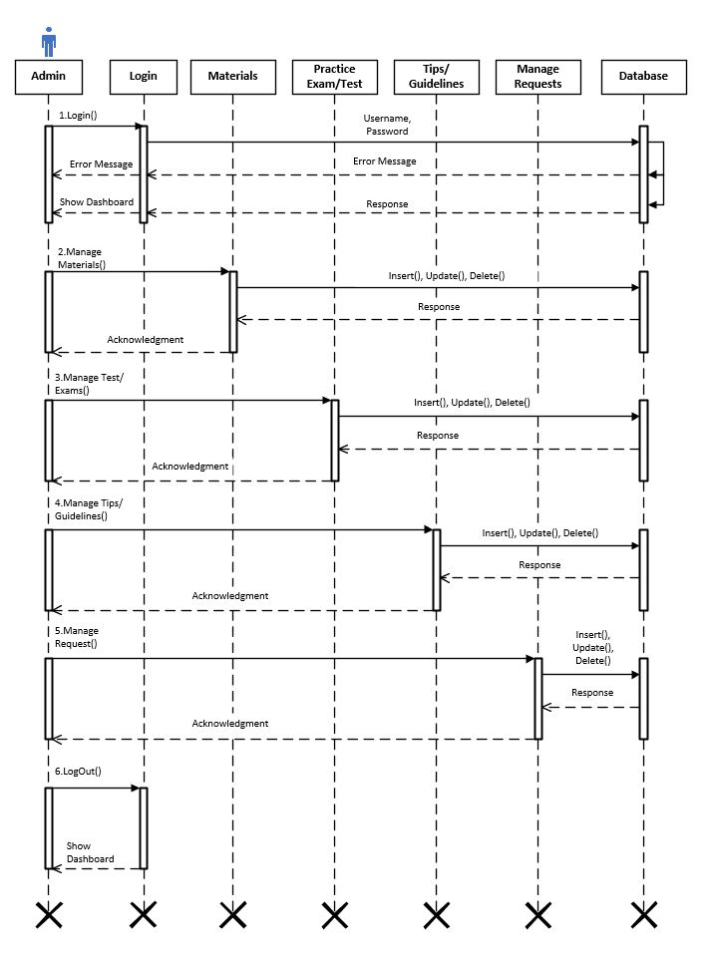

**Figure 7: Admin Sequence Diagram for CrackBook**

1. **User:**

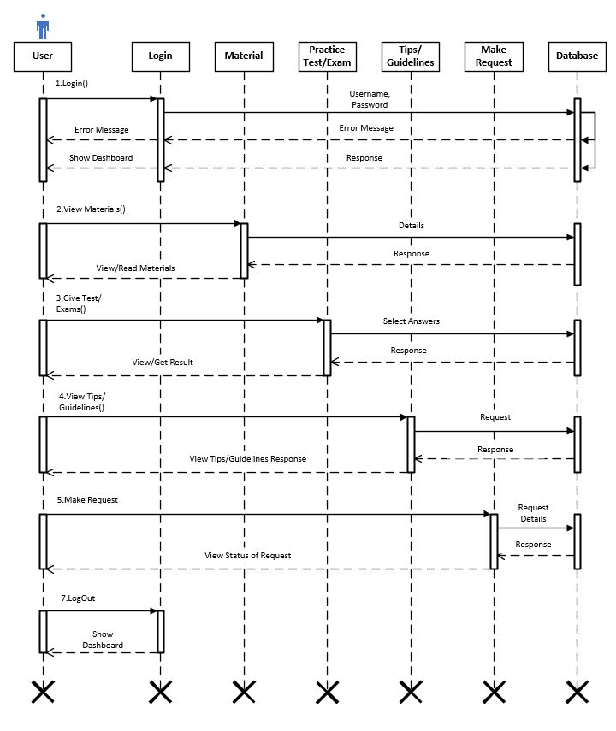

**Figure 8: User Sequence Diagram for CrackBook**

* + 1. **Activity Diagram:**

1. **Admin:**

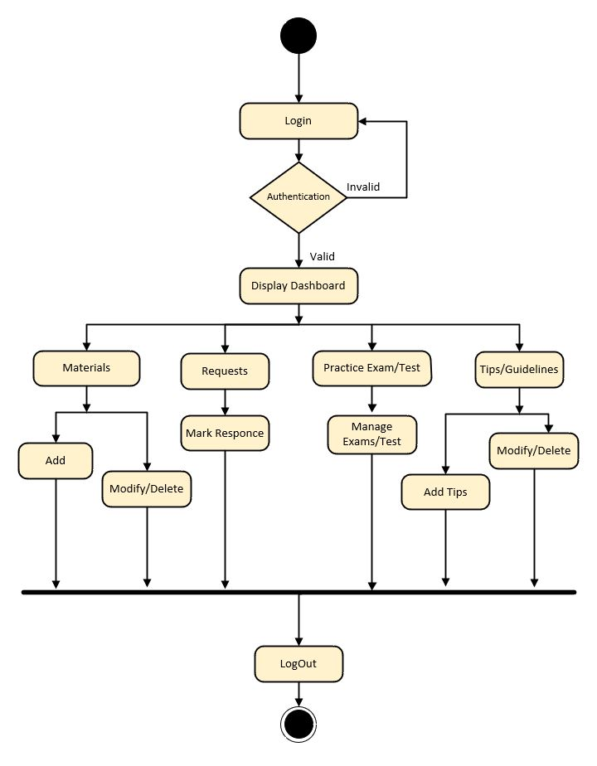

**Figure 9: Admin Activity Diagram for CrackBook**

1. **User:**

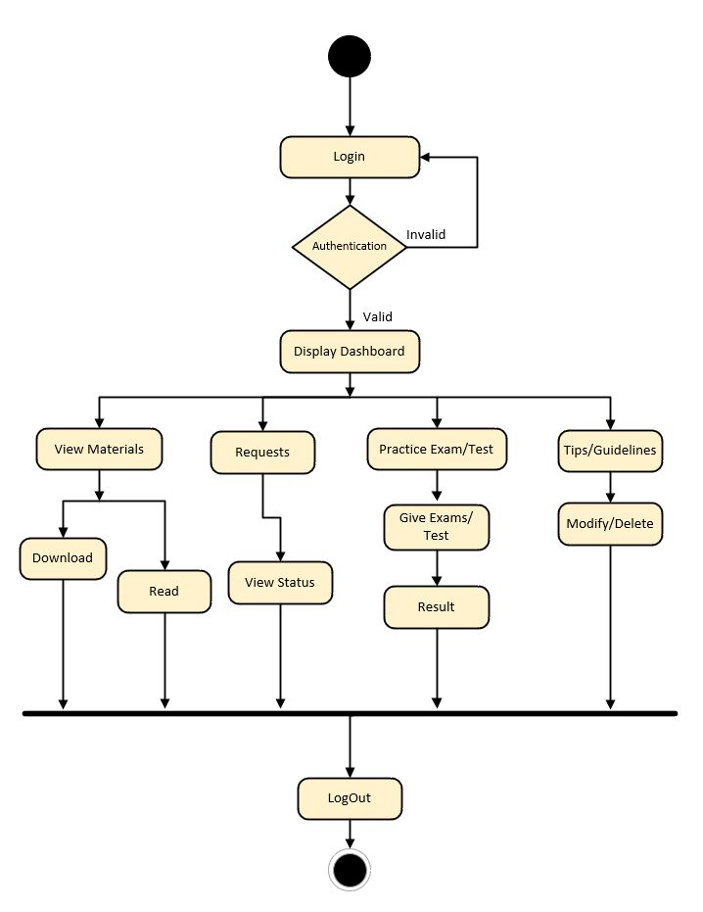

**Figure 10: User Activity Diagram for CrackBook**

* + 1. **Collaboration Diagram:**

1. **Admin:**

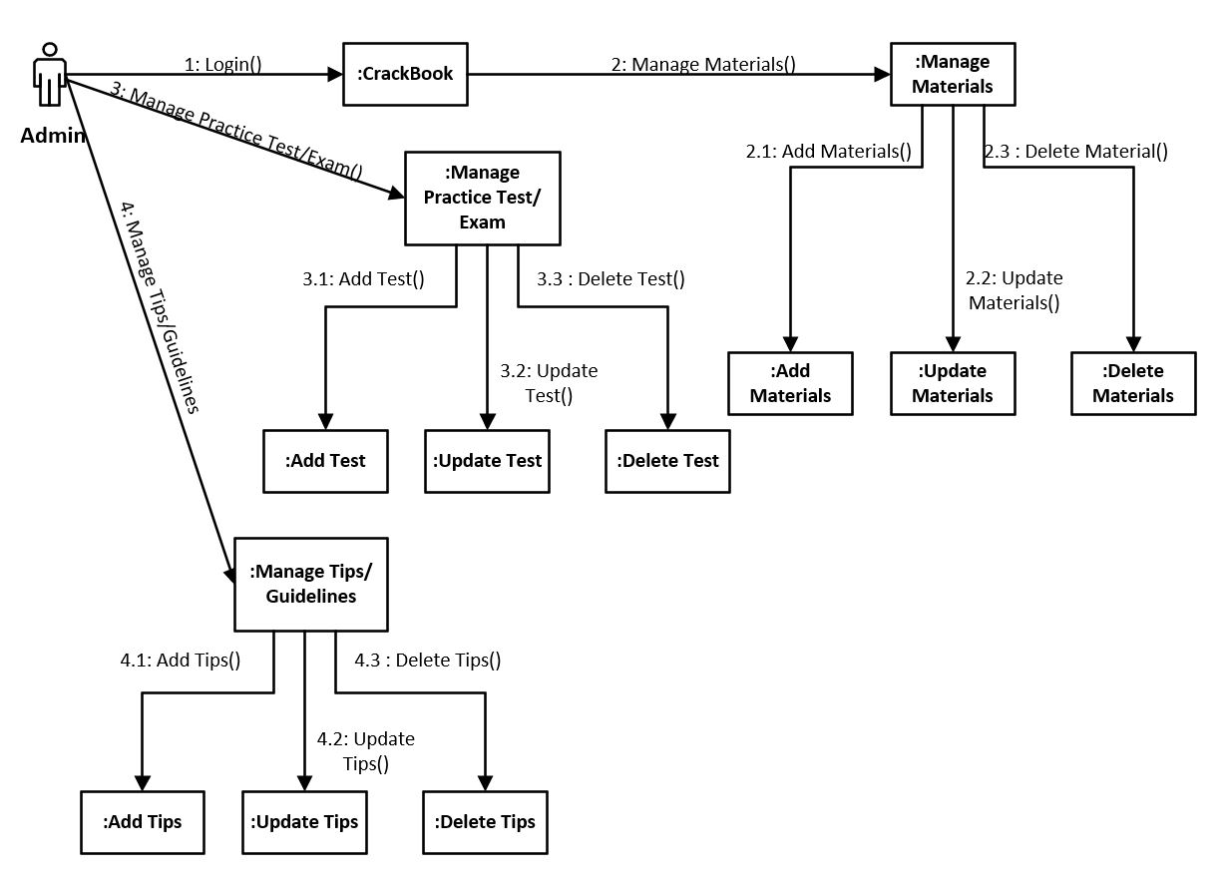

**Figure 11: Admin Collaboration Diagram for CrackBook**

1. **User:**

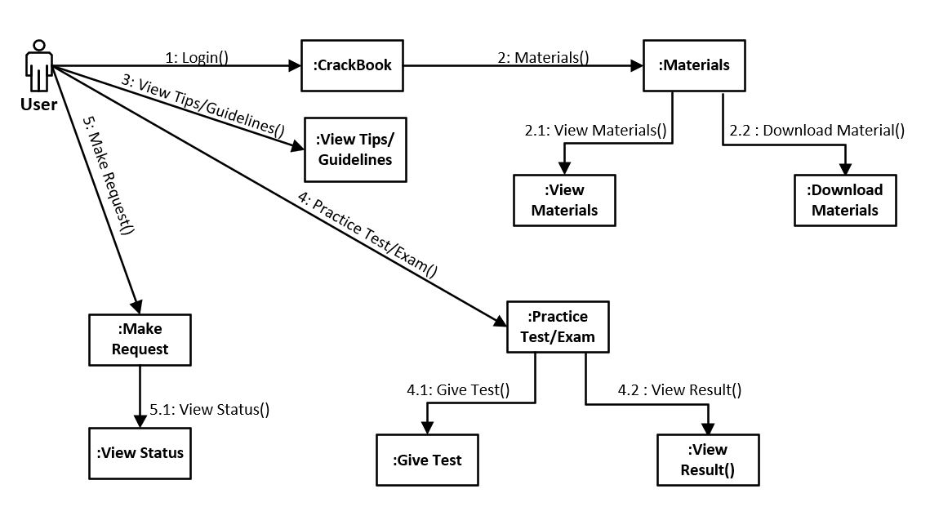

**Figure 12: User Collaboration Diagram for CrackBook**

* + 1. **Package Diagram:**

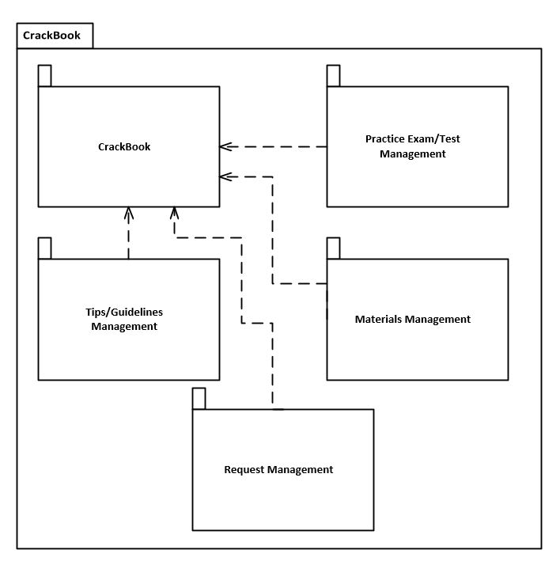

**Figure 13: Package Diagram for CrackBook**

1. **Data Dictionary:**
2. **Admin Login:**

|  |  |  |  |
| --- | --- | --- | --- |
| **Field** | **Data Type** | **Constraints** | **Description** |
| ID | Alpha-Numeric | Required | Store Unique ID of Admin |
| Password | Alpha-Numeric | Required | Store Password of Admin |

**Table 14: Admin Login**

1. **User Registration/Login:**

|  |  |  |  |
| --- | --- | --- | --- |
| **Field** | **Data Type** | **Constraints** | **Description** |
| ID | Alpha-Numeric | - | Store Unique ID of User |
| First Name | text | Required | Store Firstname of User |
| Last Name | text | Required | Store Lastname of User |
| Email | Alpha- Numeric | Required | Store Email of User |
| Mobile | Numeric | Required | Store Mobile of User |
| Username | Alpha-Numeric | Required | Store Username of User |
| Password | Alpha-Numeric | Required | Store Password of User |

**Table 15: User Login**

1. **Material:**

|  |  |  |  |
| --- | --- | --- | --- |
| **Field** | **Data Type** | **Constraints** | **Description** |
| ID | Alpha-Numeric | - | Store of Material |
| Name of Material | Alpha-Numeric | Required | Store Name of Material |
| Type of Material | text | Required | Store Name of Material |
| Date of Upload | Date | Required | Store Material Uploading Date |

**Table 16: Materials table**

1. **Tips (Guidelines):**

|  |  |  |  |
| --- | --- | --- | --- |
| **Field** | **Data Type** | **Constraints** | **Description** |
| ID | Alpha-Numeric | - | Store ID of Tips |
| Name of Tip | text | Required | Store Name of Tips |
| Type of Exam | text | Required | Store Tips that relate particular Exam |
| Date of Upload | Date & Time | Required | Store Material Uploading Date |

**Table 17: Tips/Guidelines table**

1. **Materials Request:**

|  |  |  |  |
| --- | --- | --- | --- |
| **Field** | **Data Type** | **Constraints** | **Description** |
| ID | Alpha-Numeric | - | Store Unique ID of Material Request |
| Username of person who posted request | Alpha-Numeric | Required | Store Name of User who have Requested particular Material |
| Type of Material | text | Required | Store type of Material that are requested |

**Table 18: Materials Request table**

1. **Details of Data Type:**

|  |  |  |
| --- | --- | --- |
| **Data Type** | **Description** | **Similar Like** |
| Alpha-Numeric | Used to store Alphabets and Numeric both combination Values. | MySQL varchar/ nvarchar |
| Text | Used to collect and display small amounts of unformatted text in a single line, including: Text only, such as first names, last names, material names, tip names, etc | MySQL char/ varchar |
| Date & Time | Used to store values in the format of DD/MM/YYYY or MM/DD/YYYY. | MySQL Date |

**Table 19: Details of Data Types**

# Implementation

* 1. **Form Layouts:**

**5.1.1. All Module Login:**

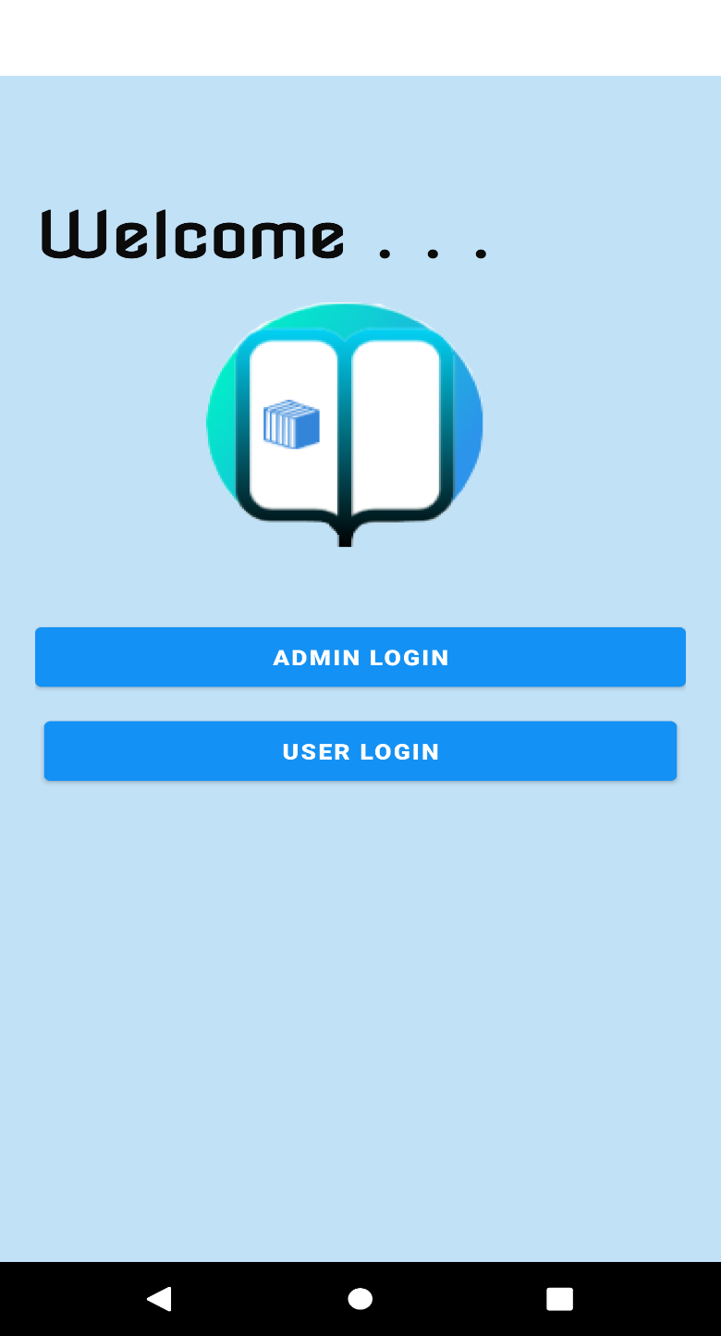

**Figure 14: Login Activity for All Modules**

**5.1.2. Admin Login:**

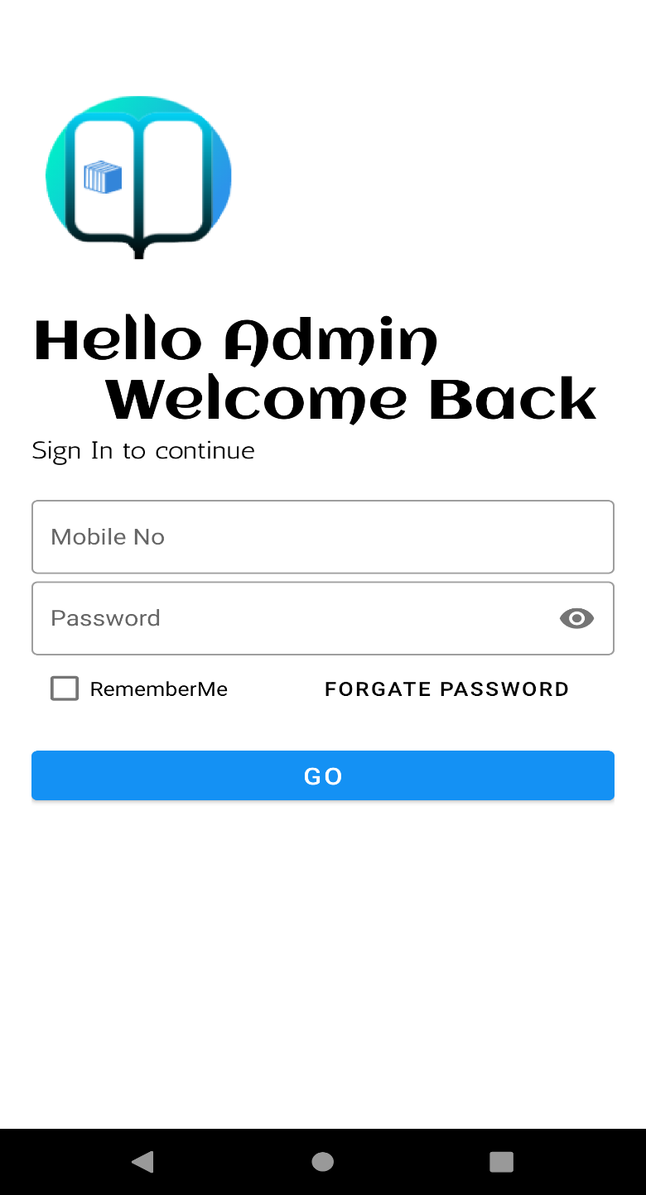

**Figure 15: Admin Login**

**5.1.3. Admin Dashboard:**

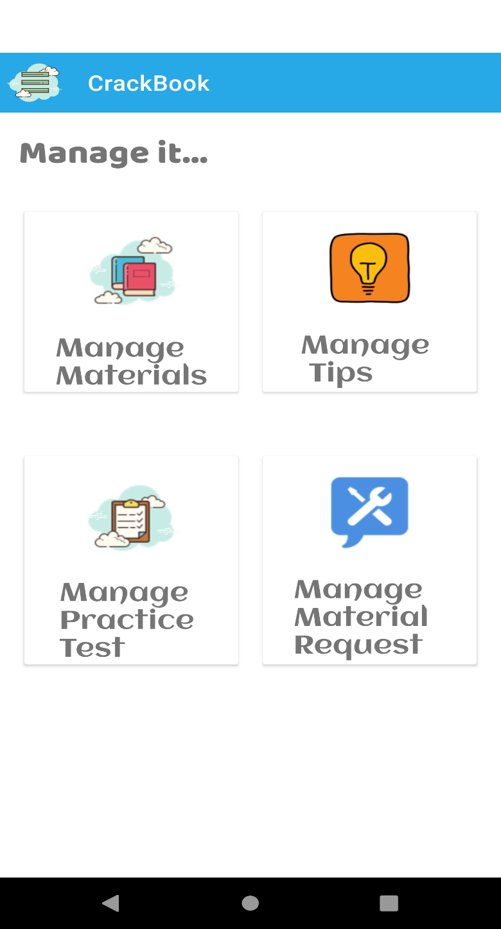

**Figure 16: Admin Login**

**5.1.4. Admin Manage Materials:**

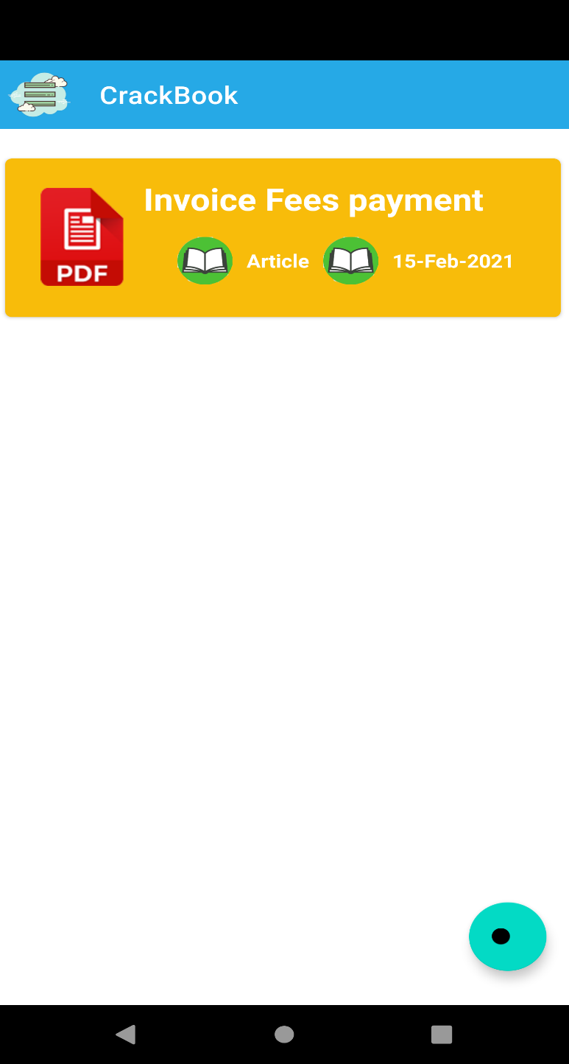

**Figure 17: Admin View and Add Materials**

**5.1.5. Admin Add Materials:**

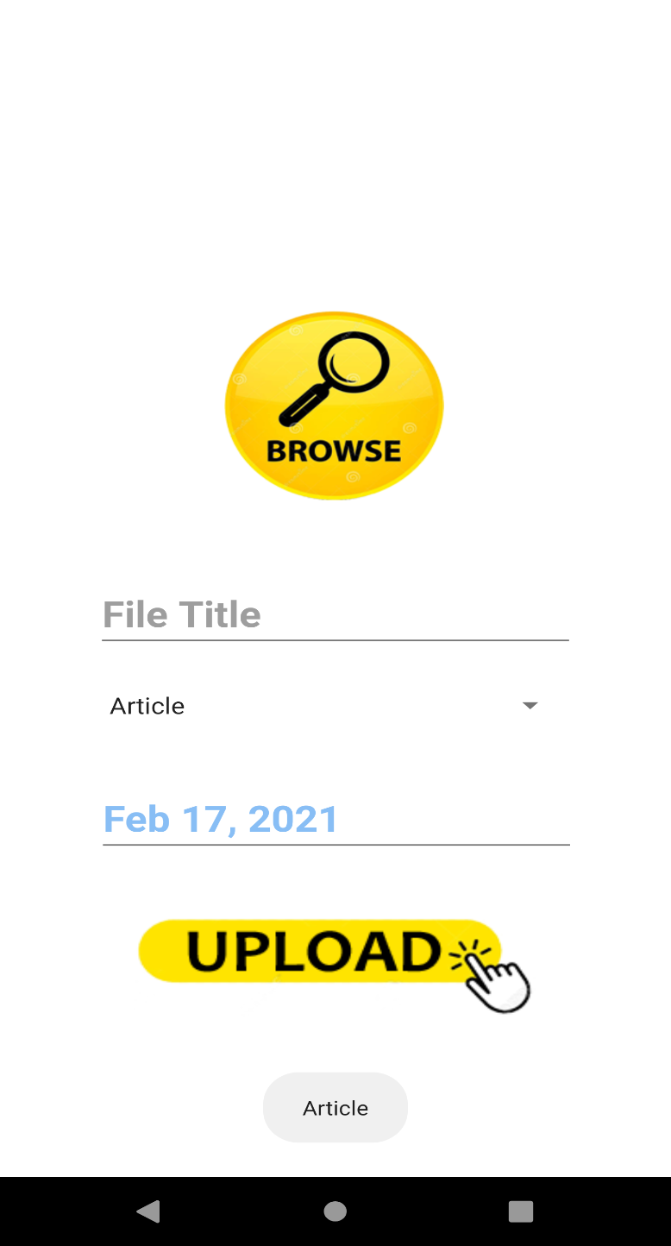

**Figure 18: Admin Add New Materials**

**5.1.6. Admin Manage Tips & Guidelines:**

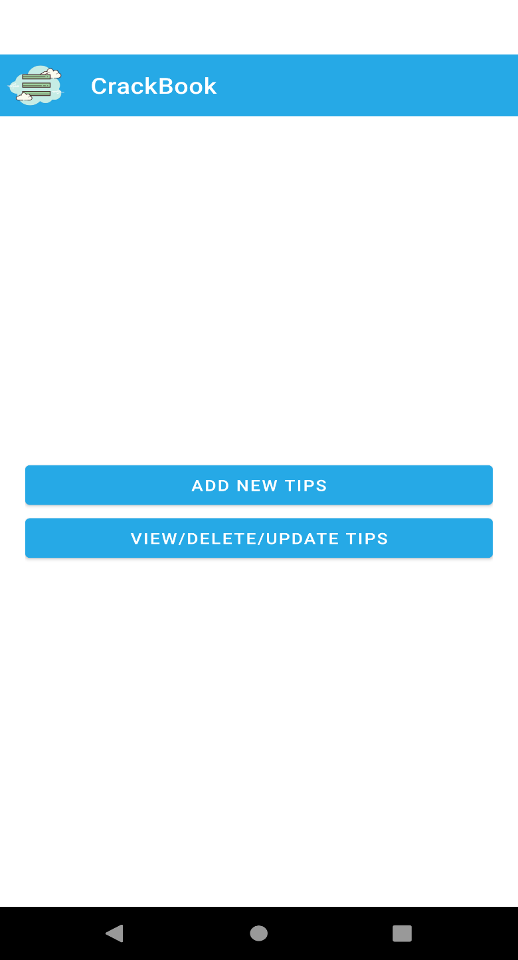

**Figure 19: Admin Manage Tips & Guidelines**

**5.1.7. Admin Add New Tips & Guidelines:**

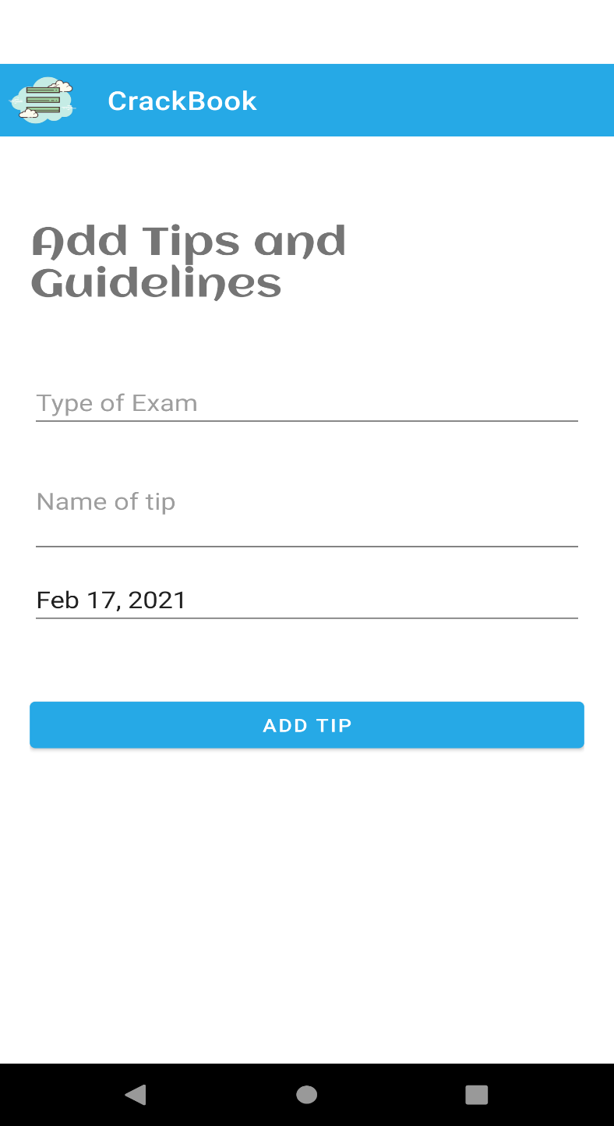

**Figure 20: Admin Add New Tips & Guidelines**

**5.1.8. Admin View Tips & Guidelines:**

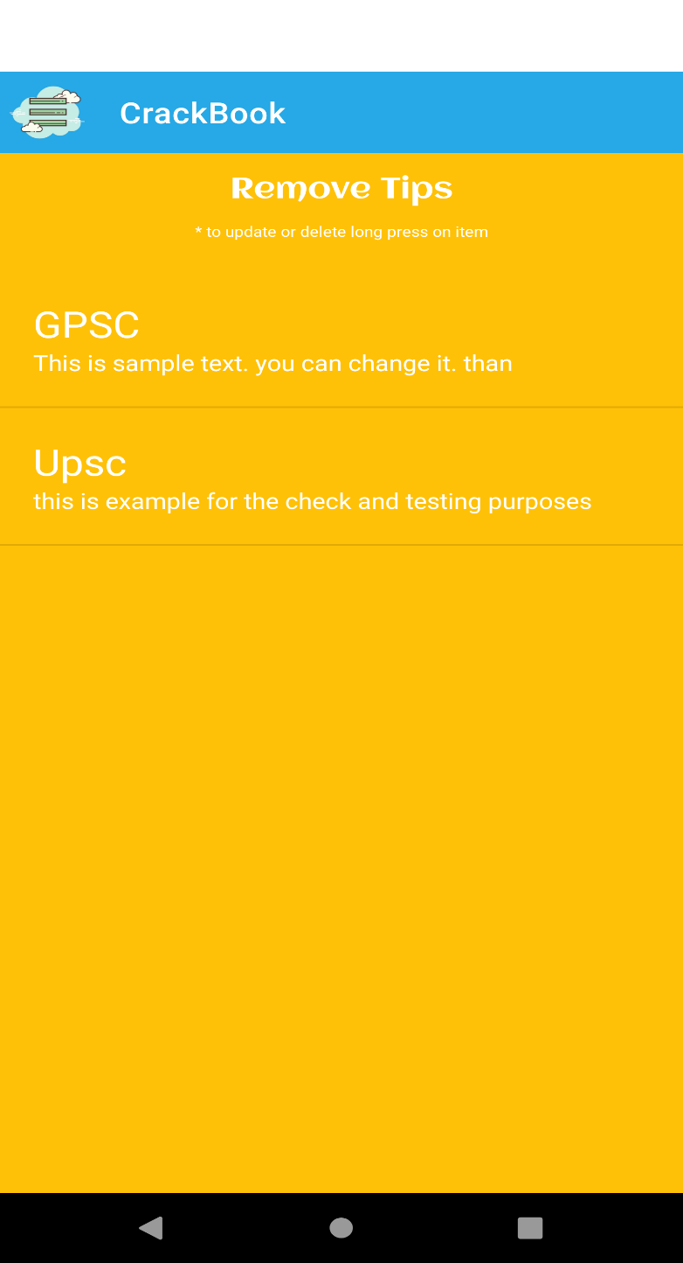

**Figure 21: Admin View Tips & Guidelines**

**5.1.9. Admin Edit or Delete Tips & Guidelines:**

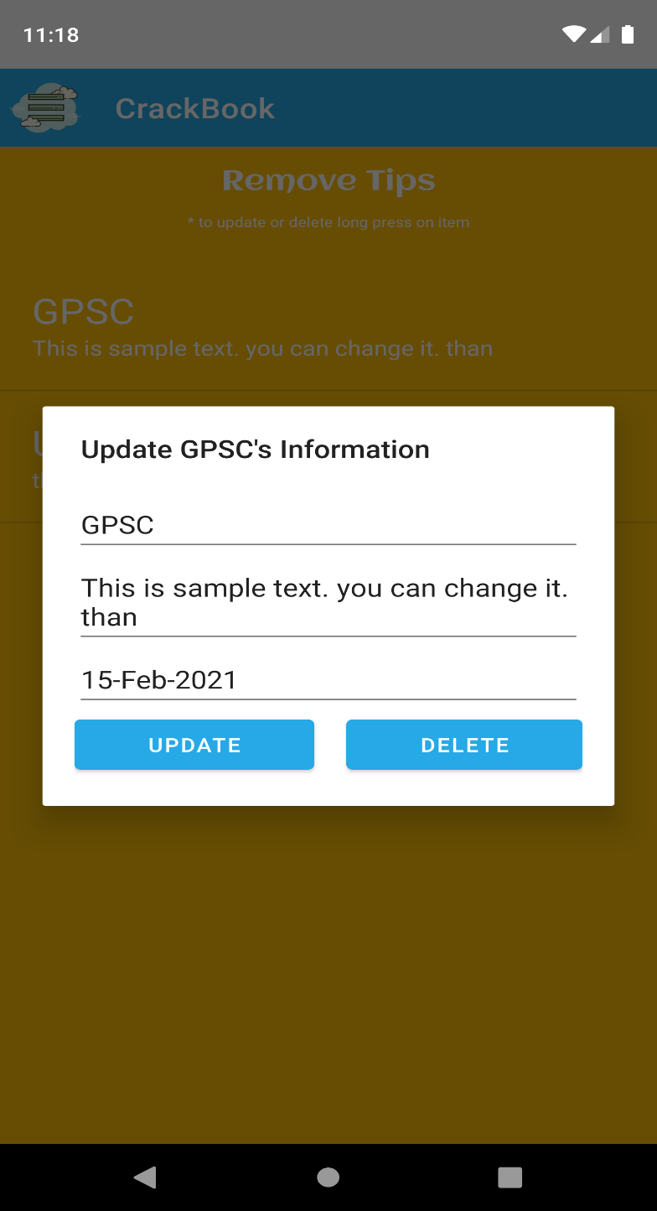

**Figure 22: Admin Edit or Delete Tips & Guidelines**

**5.1.10. Admin Manage Practice Test Categories:**

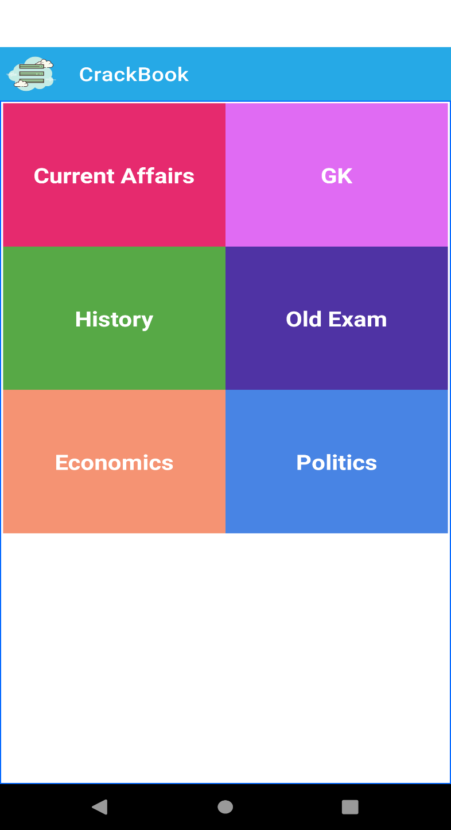

**Figure 23: Admin Manage Practice Test Categories**

**5.1.11. Admin Manage Questions Sets:**

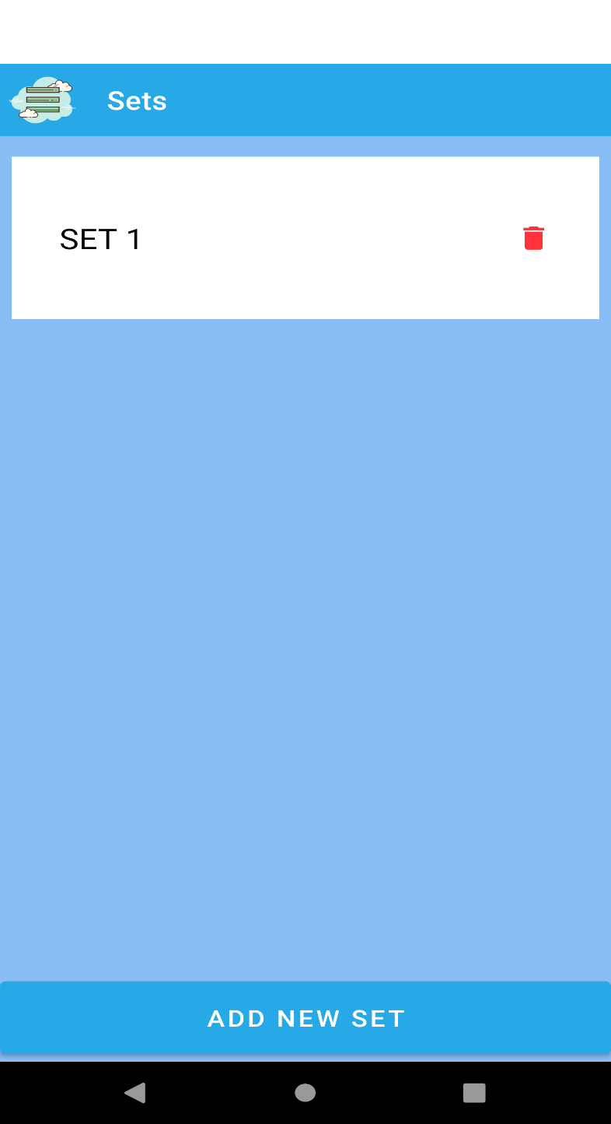

**Figure 24: Admin Manage Questions Sets**

**5.1.12. Admin Manage Questions:**

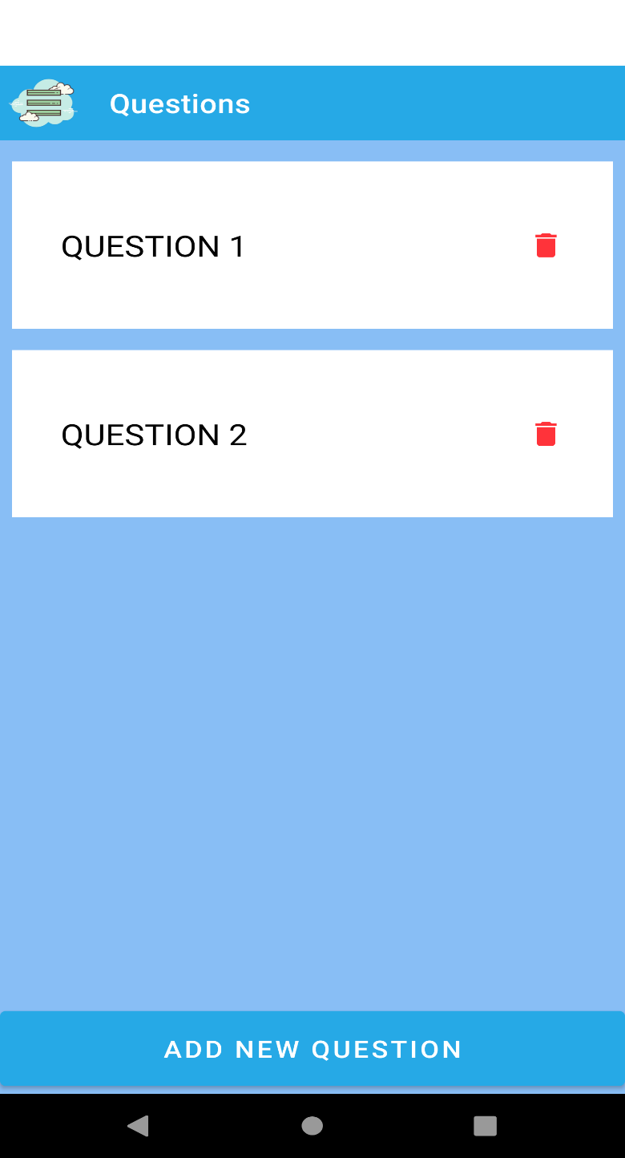

**Figure 25: Admin Manage Questions**

**5.1.13. Splash Screen:**



**Figure 26: Splash Screen**

**5.1.14. User Registration:**

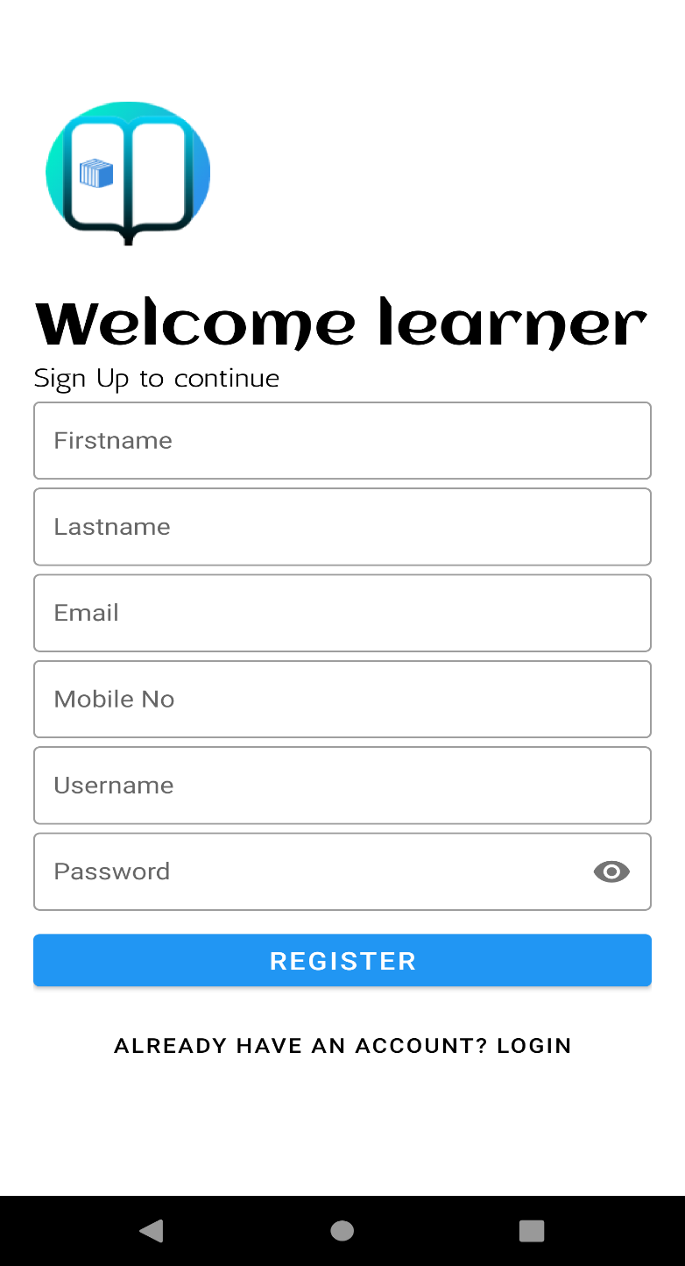

**Figure 27: User New Registration**

**5.1.15. User Login:**

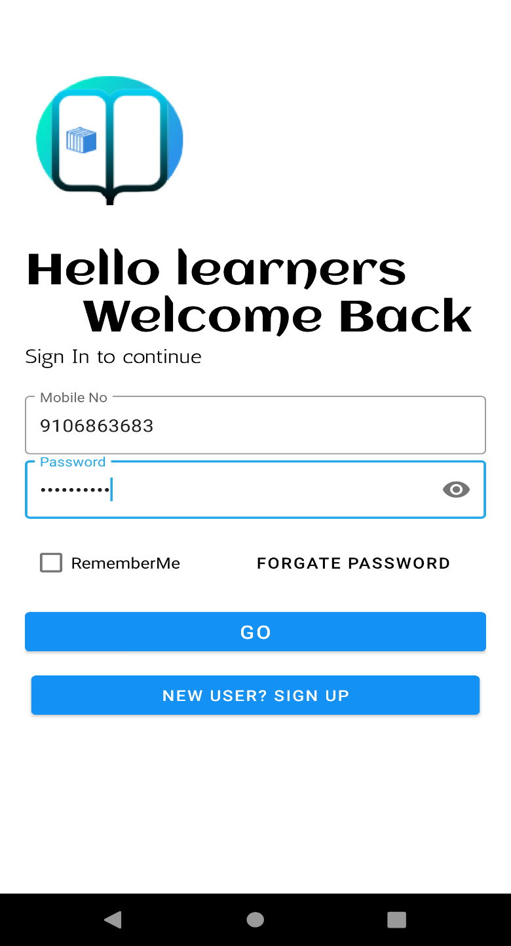

**Figure 28: User Login**

**5.1.16. User Dashboard:**

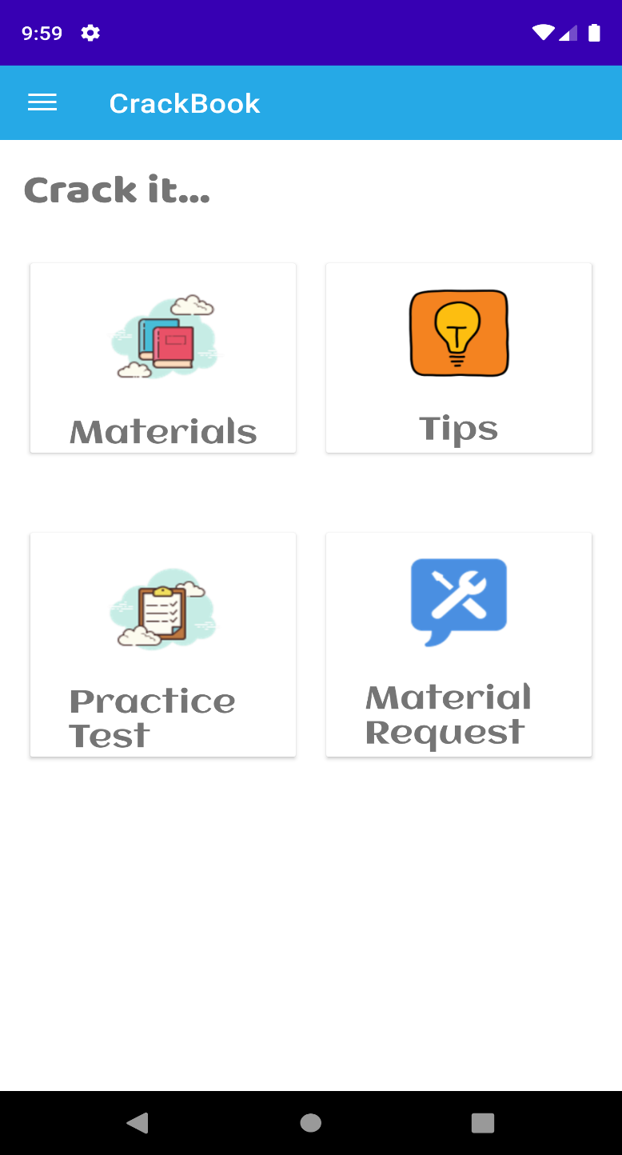

**Figure 29: User Dashboard**

**5.1.17. User Navigation Drawer:**

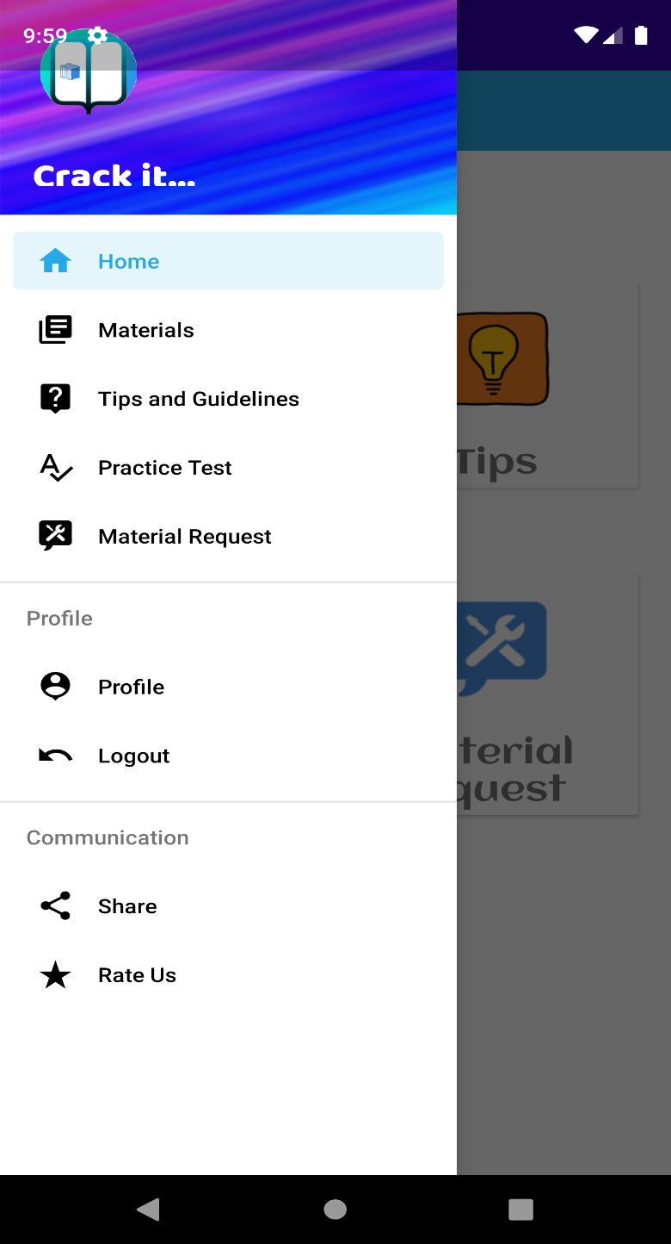

**Figure 30: User Navigation Drawer**

**5.1.18. User View Materials:**



**Figure 31: User View Materials**

**5.1.19. User View Tips & Guidelines:**

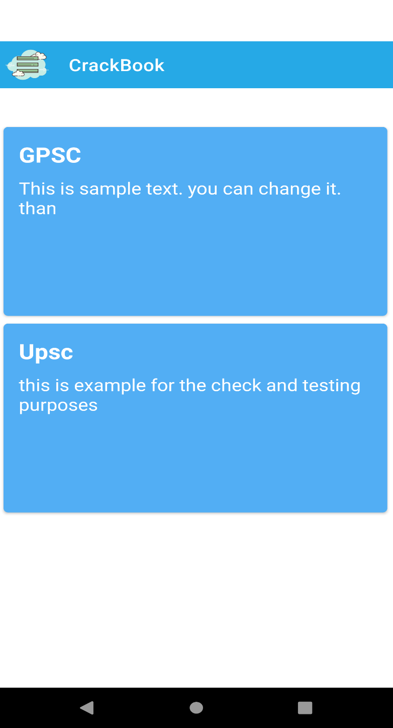

**Figure 32: User View Tips & Guidelines**

**5.1.20. User Practice Test Categories:**

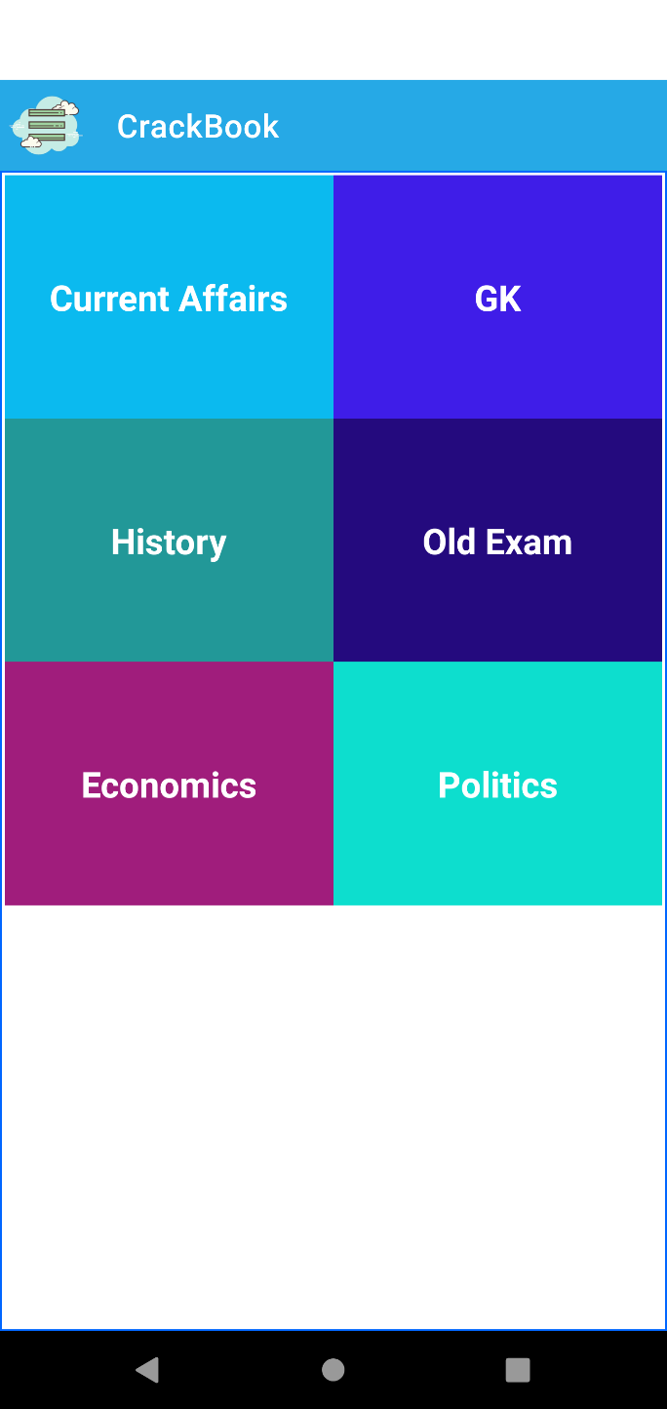

**Figure 33: User Practice Categories**

**5.1.21. User Practice Test Sets:**

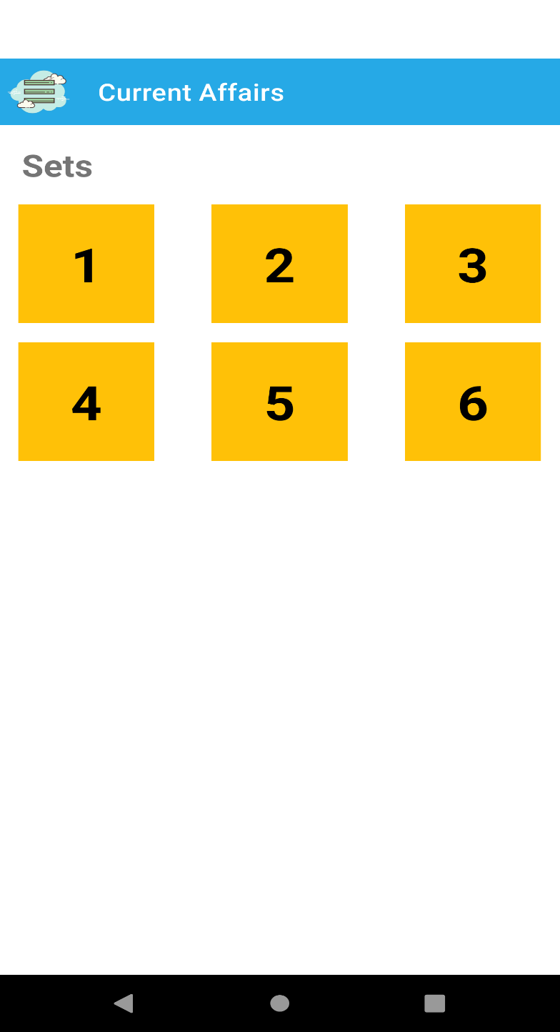

**Figure 34: User Practice Test Sets**

**5.1.22. User Share App Link:**

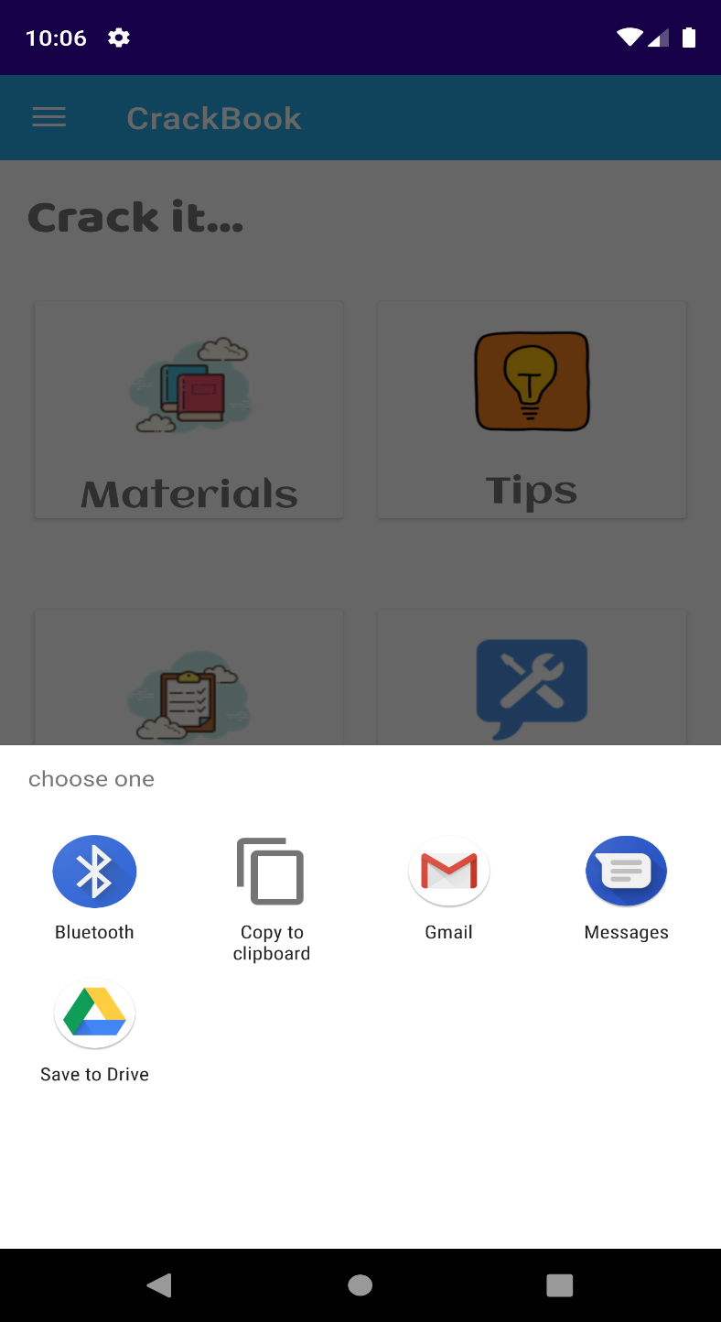

**Figure 35: User Share App Link**

**5.1.23. User Rate Us:**

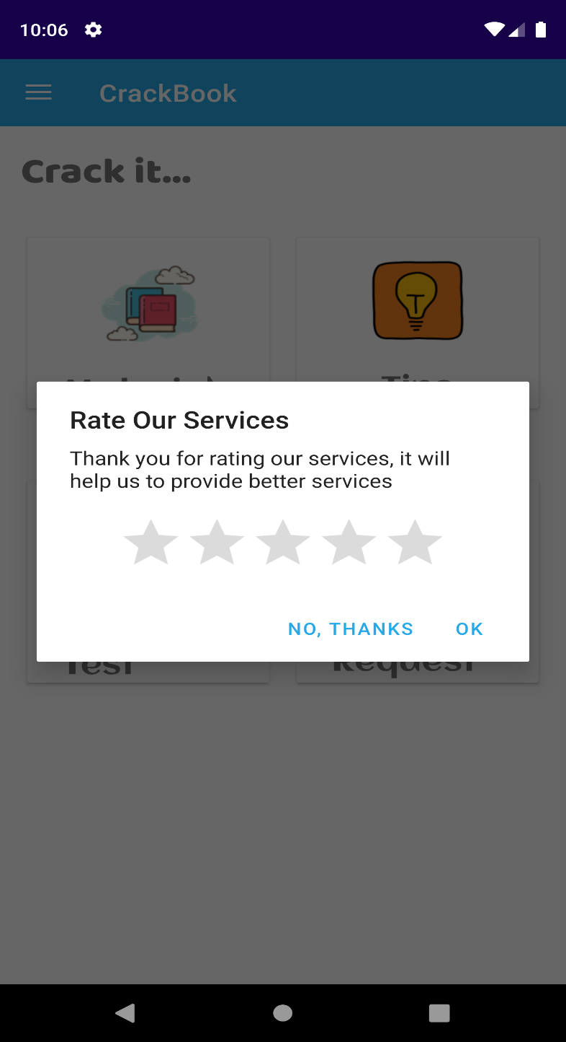

**Figure 36: User Rate Services**

**5.1.24. User Logout Alert and Back Pressed Alert:**

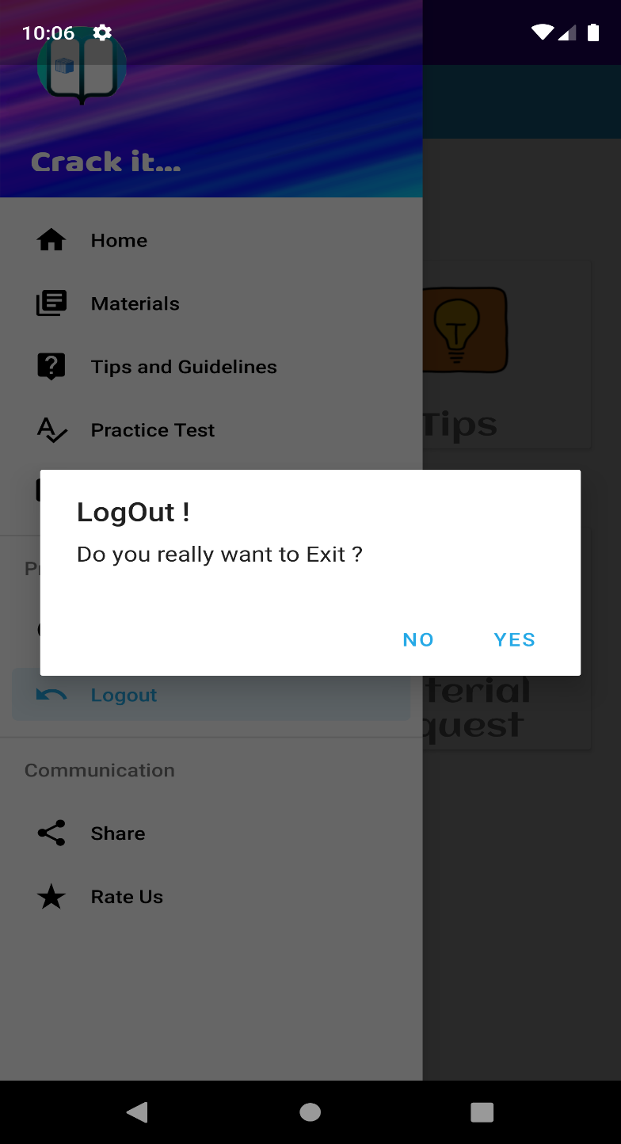

**Figure 37: User Logout Alert and Back Pressed Alert**

**5.1.25. User Practice Test Activity:**

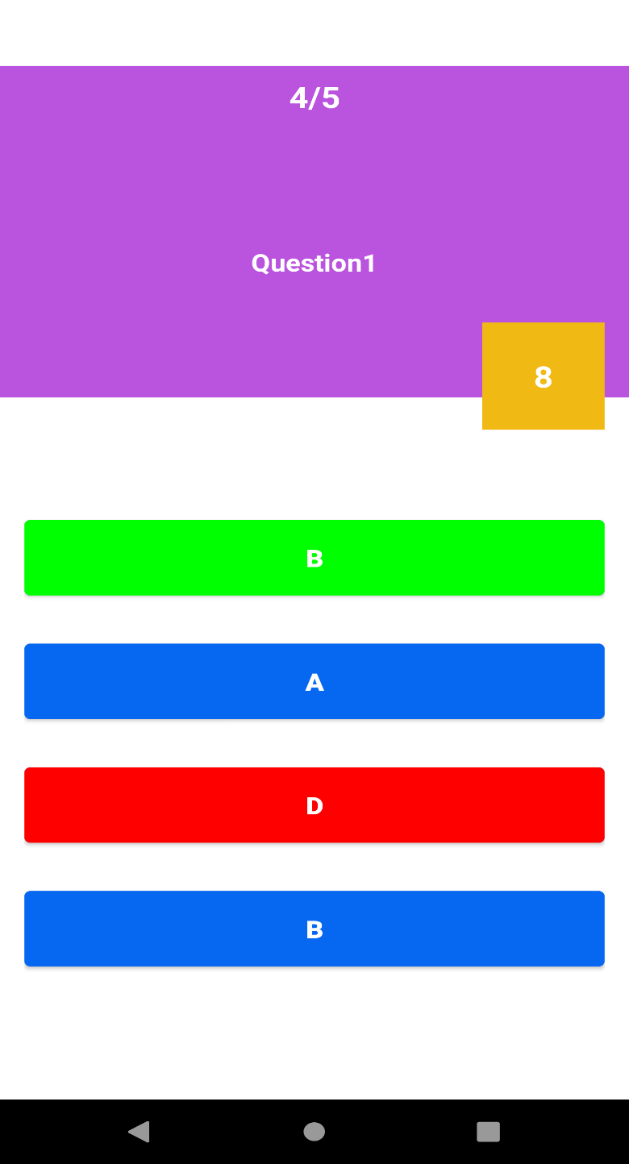

**Figure 38: User Practice Test Question Activity**

**5.1.25. User Practice Test Score:**



**Figure 39: User Practice Test Score**

* 1. **Coding Conventions:**
     1. **Add New Admin:**

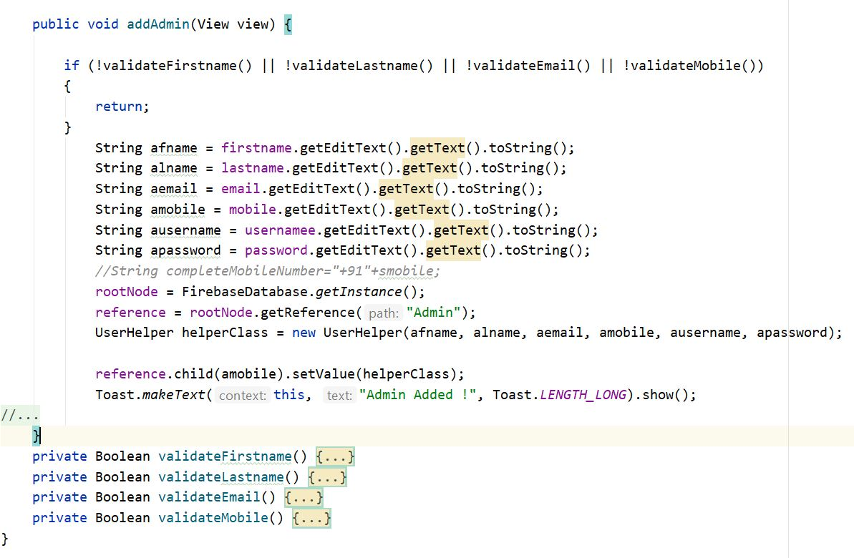

* + 1. **Admin Login:**

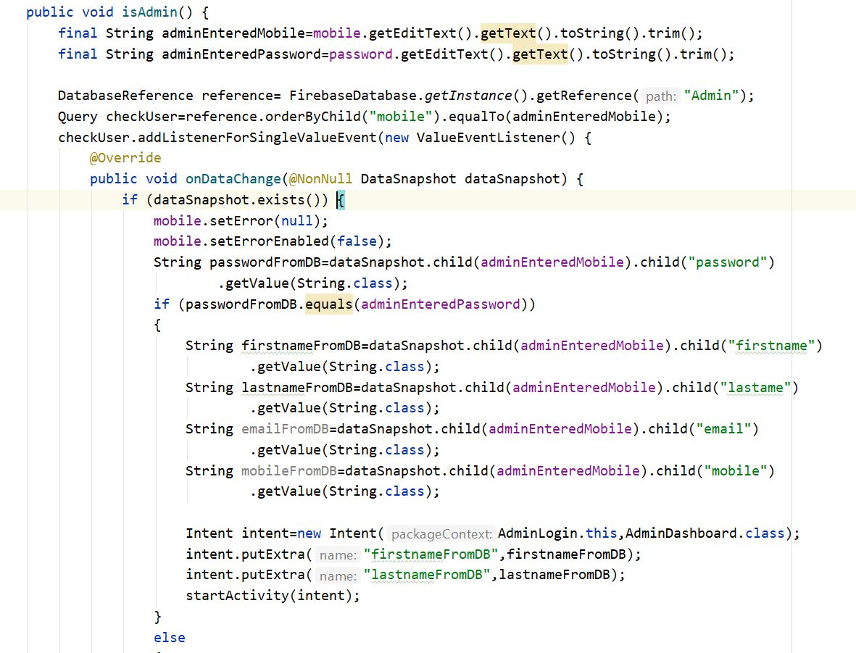

* + 1. **Admin Add Material:**

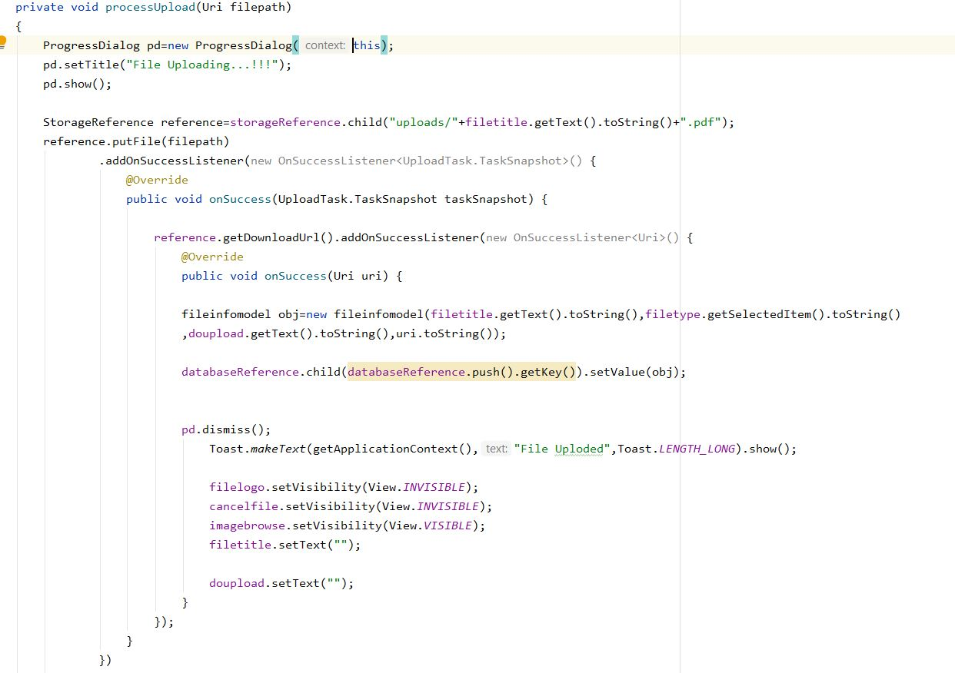

* + 1. **Admin Add Practice Test Category:**

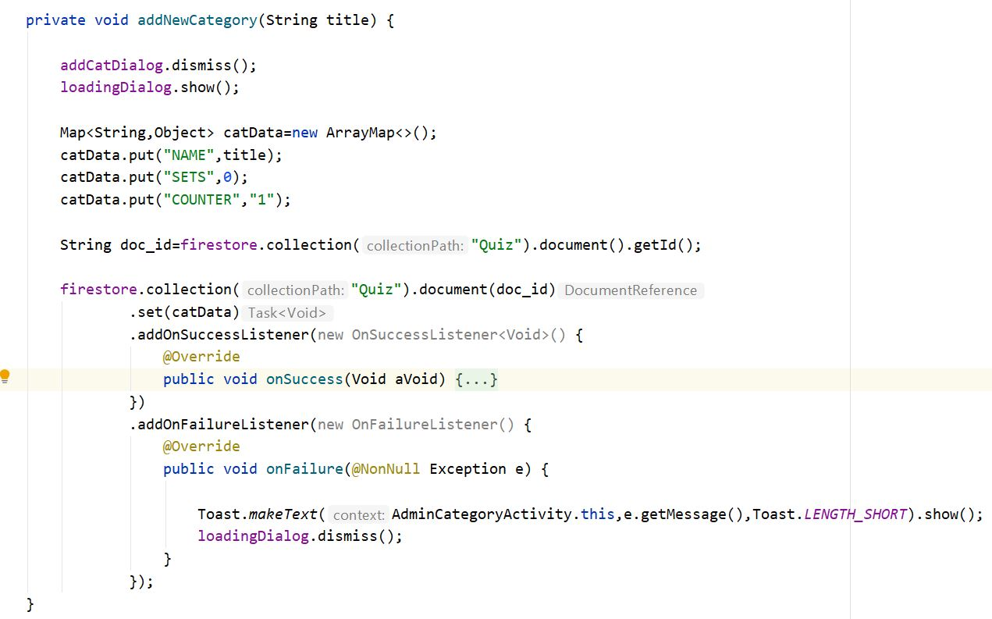

* + 1. **Admin Add Practice Test Set in Category:**

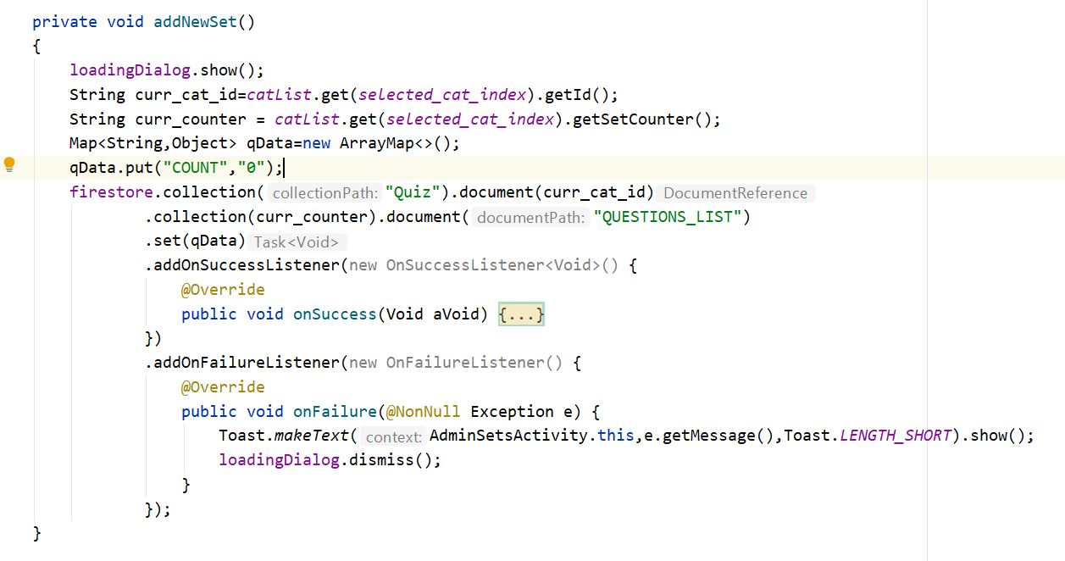

* + 1. **Admin Add Practice Test Question:**

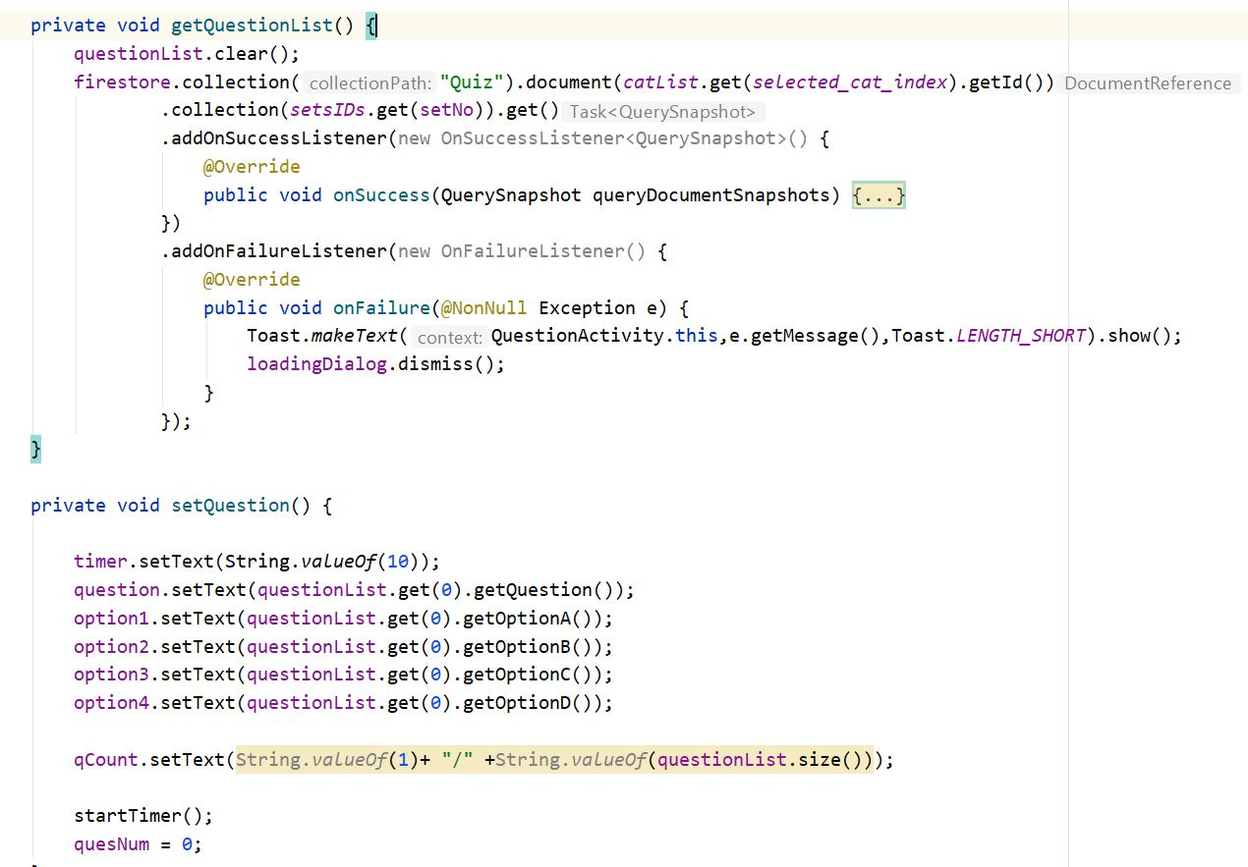

* + 1. **Admin Add Tips & Guidelines:**

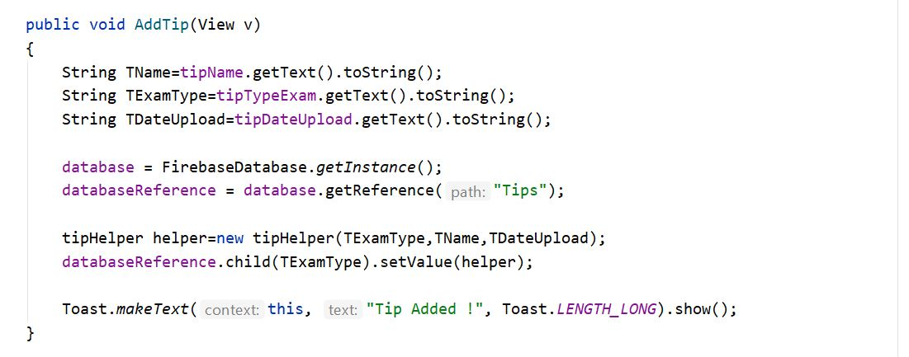

* + 1. **Admin Delete Tips & Guidelines:**

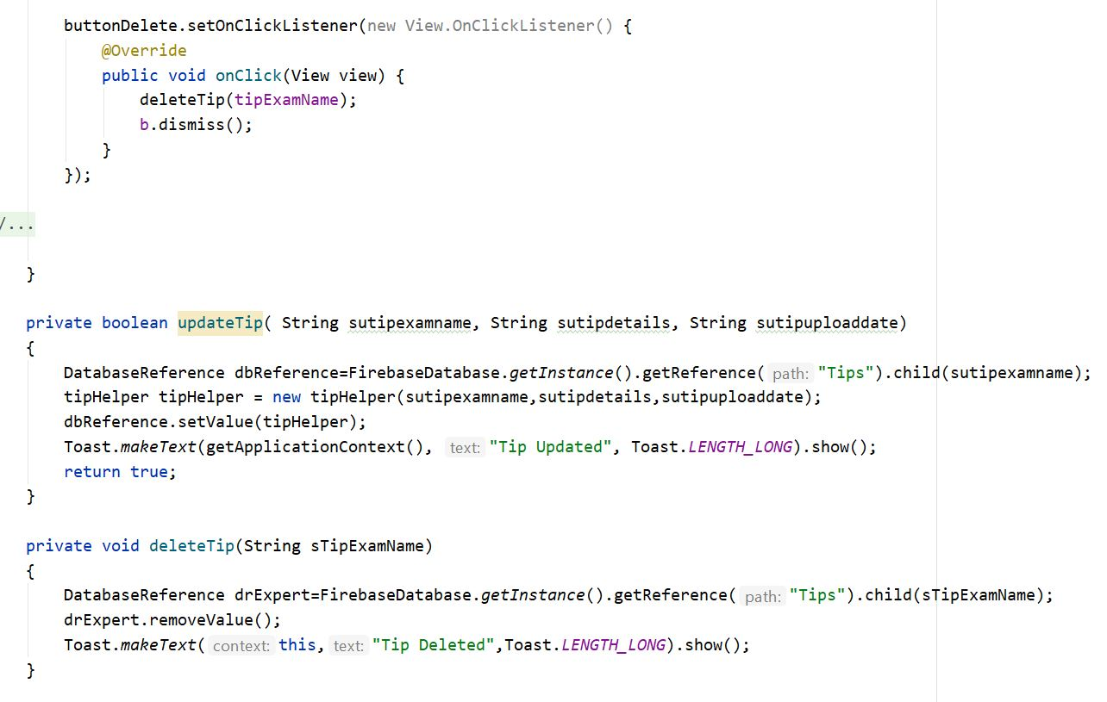

* + 1. **Admin Edit/Update Tips & Guidelines:**

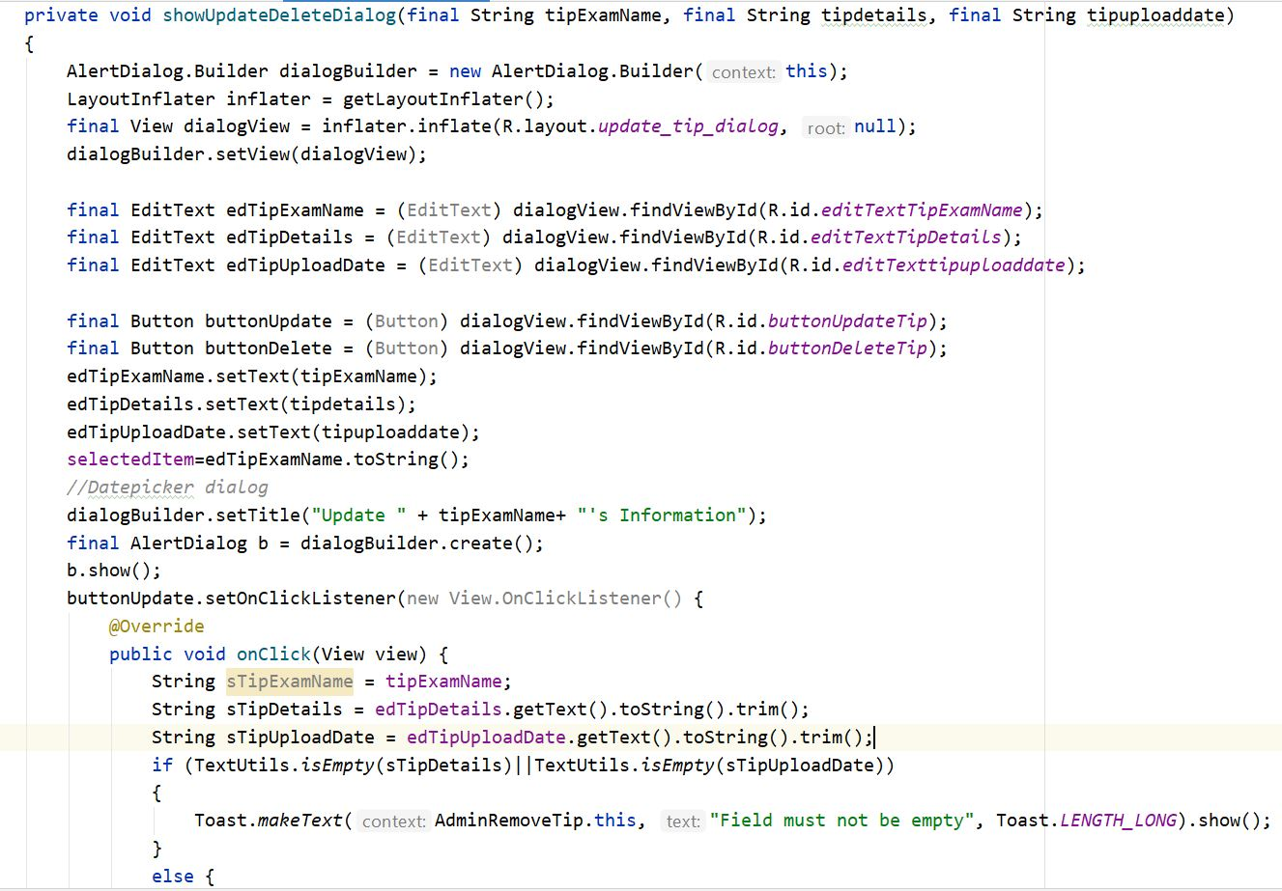

* + 1. **Admin Edit/Update Tips & Guidelines:**



* + 1. **User Register User:**

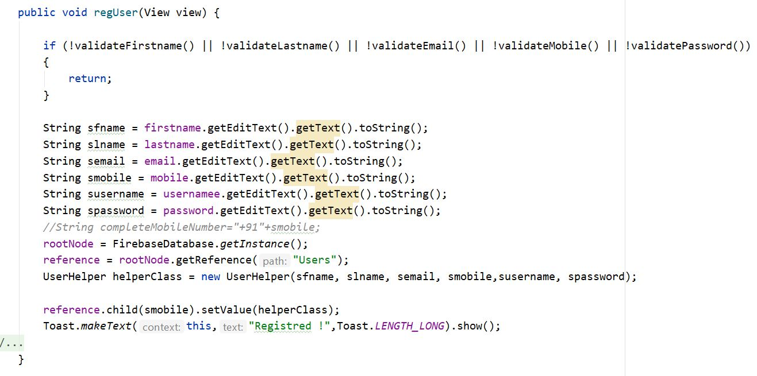

* + 1. **User View Materials:**

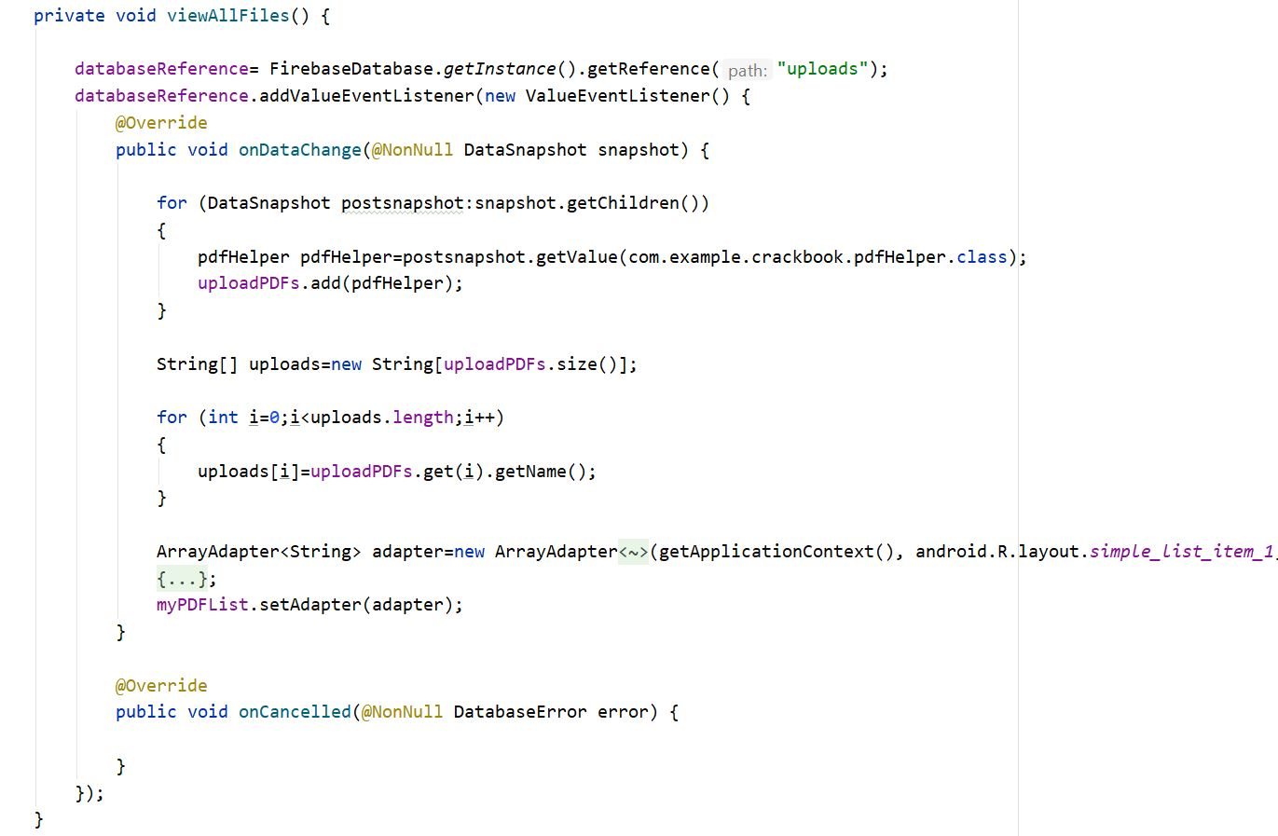

* + 1. **User View Tips:**



* + 1. **User Practice Test:**

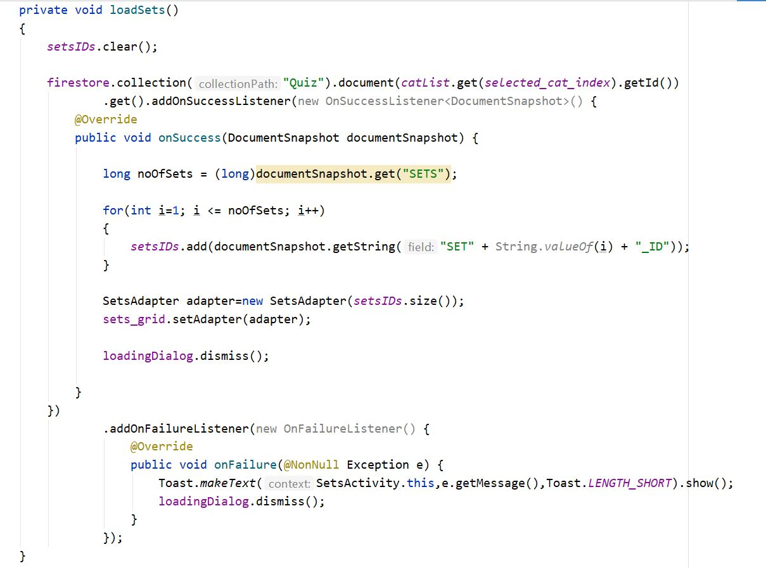

# Testing

* 1. **Test Strategy:**
* In our scenario test strategy is used to test the functionality of our system. We have to use to cover all scenarios. Main focus is on Functional Testing. In Functional Testing test case are used to test the application interface.
* In our system testing is going to be done at individual module level. Each module will be undergone to Unit Testing and expected result is supposed to be same as actual result.
  1. **Test Cases:**
     1. **Admin Login:**

|  |  |
| --- | --- |
| Test Case ID | TC001 |
| Test Case Summary | This test case was conducted for checking admin login. |
| Related Requirement | RS001 |
| Prerequisite | Admin must be registered in system. |
| Test Procedure | 1. Enter the mobile number and password. 2. Check the mobile number and password is correct or not. 3. Click on login button. |
| Test Data | Mobile Number: 9106863683  Password: ******** |
| Expected Result | Admin enters into the system. |
| Actual Result | Admin can view the Admin Dashboard. |
| Status | Pass |
| Remarks | This test case is for login into the system. |
| Created By | Nayan Satani |
| Date of Creation | 07/03/2021 |
| Executed By | Nayan Satani |
| Date of Execution | 07/03/2021 |
| Test Environment | Android Emulator |

**Table 20: Test Case of Admin Login**

* + 1. **Add New Admin:**

|  |  |
| --- | --- |
| Test Case ID | TC002 |
| Test Case Summary | This test case was conducted for add new admin. |
| Related Requirement | RS002 |
| Prerequisite | Admin must be logged into the system. |
| Test Procedure | 1. Enter First Name, Last Name, Email, Mobile Number, and Password. 2. Click on add button. |
| Test Data | First Name: Nayan  Last Name: satani  Email: nayansatani@gmail.com  Mobile number: 9106863683  Password: ******** |
| Expected Result | Add admin in system. |
| Actual Result | Admin data can be Added successfully. |
| Status | Pass |
| Remarks | This test case for add new admin. |
| Created By | Nayan Satani |
| Date of Creation | 07/03/2021 |
| Executed By | Nayan Satani |
| Date of Execution | 07/03/2021 |
| Test Environment | Android Emulator |

**Table 21: Admin Add New Admin**

* + 1. **Admin Add New Materials:**

|  |  |
| --- | --- |
| Test Case ID | TC003 |
| Test Case Summary | This test case was conducted for add new materials. |
| Related Requirement | RS003 |
| Prerequisite | Admin must be logged-in in the app/system. |
| Test Procedure | 1. Enter Material Name, Select Type of Material, Select Material File. 2. Click on Upload button. |
| Test Data | Material Name (File name): Feb 2020 Current Affaires  Material Type: Current Affaires  Material File: Feb 2020 CA.pdf |
| Expected Result | Added Material in system. |
| Actual Result | Material added successfully. |
| Status | Pass |
| Remarks | This test case for add new material. |
| Created By | Nayan Satani |
| Date of Creation | 07/03/2021 |
| Executed By | Nayan Satani |
| Date of Execution | 07/03/2021 |
| Test Environment | Android Emulator |

**Table 22: Admin Add New Materials**

* + 1. **Add New Tips & Guidelines:**

|  |  |
| --- | --- |
| Test Case ID | TC004 |
| Test Case Summary | This test case was conducted for add new tips & guidelines. |
| Related Requirement | RS004 |
| Prerequisite | Admin must be logged-in in the app/system. |
| Test Procedure | 1. Enter Type of Exam (like, GPSC), Name of Tip.  2. Click on Add Tip button. |
| Test Data | Type of Exam: GPSC  Name of Tip: To appear GPSC exam, examiner should be greater than 21 years. |
| Expected Result | Added New Tips in system. |
| Actual Result | Tip added successfully. |
| Status | Pass |
| Remarks | This test case for add new tips. |
| Created By | Nayan Satani |
| Date of Creation | 07/03/2021 |
| Executed By | Nayan Satani |
| Date of Execution | 07/03/2021 |
| Test Environment | Android Emulator |

**Table 23: Add New Tips & Guidelines**

* + 1. **Delete/Update Tips & Guidelines:**

|  |  |
| --- | --- |
| Test Case ID | TC005 |
| Test Case Summary | This test case was conducted for Delete/Update tips & guidelines. |
| Related Requirement | RS005 |
| Prerequisite | Admin must be logged-in in the app/system. |
| Test Procedure | 1. Enter Type of Exam (like, GPSC), Name of Tip.  2. Click on Delete/Update button. |
| Test Data | Type of Exam: GPSC  Name of Tip: To appear GPSC exam, examiner should be greater than 21 years. |
| Expected Result | Updated/Deleted Tip in system. |
| Actual Result | Tip Updated/Deleted successfully. |
| Status | Pass |
| Remarks | This test case for add new tips. |
| Created By | Nayan Satani |
| Date of Creation | 07/03/2021 |
| Executed By | Nayan Satani |
| Date of Execution | 07/03/2021 |
| Test Environment | Android Emulator |

**Table 24: Delete/Update Tips & Guidelines**

* + 1. **Add New Practice Test Categories:**

|  |  |
| --- | --- |
| Test Case ID | TC006 |
| Test Case Summary | This test case was conducted for Add New Practice Test Categories. |
| Related Requirement | RS006 |
| Prerequisite | Admin must be logged-in in the app/system. |
| Test Procedure | 1. Name of the Category.  2. Click on Add Category button. |
| Test Data | Category Name: General Knowledge |
| Expected Result | Added Category in system. |
| Actual Result | Added Category successfully. |
| Status | Pass |
| Remarks | This test case for add new category. |
| Created By | Nayan Satani |
| Date of Creation | 07/03/2021 |
| Executed By | Nayan Satani |
| Date of Execution | 07/03/2021 |
| Test Environment | Android Emulator |

**Table 25: Add New Practice Test Category**

* + 1. **Add New Practice Test Set in category:**

|  |  |
| --- | --- |
| Test Case ID | TC007 |
| Test Case Summary | This test case was conducted for Add New Practice Test Set in Category. |
| Related Requirement | RS007 |
| Prerequisite | Admin must be logged-in in the app/system. |
| Test Procedure | 1. Click on Add Set button. |
| Test Data | Set Number: Set 1 (Auto-Increment) |
| Expected Result | Added Set in system. |
| Actual Result | Set added successfully. |
| Status | Pass |
| Remarks | This test case for add new Set in category. |
| Created By | Nayan Satani |
| Date of Creation | 07/03/2021 |
| Executed By | Nayan Satani |
| Date of Execution | 07/03/2021 |
| Test Environment | Android Emulator |

**Table 26: Add New Practice Test Set in Category**

* + 1. **Add New Practice Test Question in sets:**

|  |  |
| --- | --- |
| Test Case ID | TC008 |
| Test Case Summary | This test case was conducted for Add New Practice Test Questions in sets. |
| Related Requirement | RS008 |
| Prerequisite | Admin must be logged-in in the app/system. |
| Test Procedure | 1. Question.  2. Option A.  3. Option B.  4. Option C.  5. Option D.  6. Correct Answer Number (Like, 2 Option B) |
| Test Data | Question: What is Capital of India?  Option A: Mumbai  Option B: Delhi  Option C: Jaipur  Option D: Pune  Correct Answer: 2 |
| Expected Result | Added Question in system. |
| Actual Result | Question successfully. |
| Status | Pass |
| Remarks | This test case for add new question. |
| Created By | Nayan Satani |
| Date of Creation | 07/03/2021 |
| Executed By | Nayan Satani |
| Date of Execution | 07/03/2021 |
| Test Environment | Android Emulator |

**Table 27: Add New Practice Test Question in Sets**

* + 1. **Edit/Update Practice Test Question:**

|  |  |
| --- | --- |
| Test Case ID | TC009 |
| Test Case Summary | This test case was conducted for Edit/Update Practice Test Question. |
| Related Requirement | RS009 |
| Prerequisite | Admin must be logged-in in the app/system. |
| Test Procedure | 1. Question.  2. Option A.  3. Option B.  4. Option C.  5. Option D.  6. Correct Answer Number (Like, 2 Option B) |
| Test Data | Question: What is Capital of India?  Option A: Mumbai  Option B: Delhi  Option C: Jaipur  Option D: Pune  Correct Answer: 2 |
| Expected Result | Question updated in system. |
| Actual Result | Question updated successfully. |
| Status | Pass |
| Remarks | This test case for updated question. |
| Created By | Nayan Satani |
| Date of Creation | 07/03/2021 |
| Executed By | Nayan Satani |
| Date of Execution | 07/03/2021 |
| Test Environment | Android Emulator |

**Table 28: Edit/updated Practice Test Question**

* + 1. **User Login:**

|  |  |
| --- | --- |
| Test Case ID | TC010 |
| Test Case Summary | This test case was conducted for checking user login. |
| Related Requirement | RS010 |
| Prerequisite | User must be registered in system. |
| Test Procedure | 1. Enter the mobile number and password. 2. Check the mobile number and password is correct or not. 3. Click on login button. |
| Test Data | Mobile number: 9106863683  Password: ******** |
| Expected Result | User enters into the system. |
| Actual Result | User can view the User Dashboard. |
| Status | Pass |
| Remarks | This test case for user login into the system. |
| Created By | Nayan Satani |
| Date of Creation | 07/03/2021 |
| Executed By | Nayan Satani |
| Date of Execution | 07/03/2021 |
| Test Environment | Android Emulator |

**Table 29: User Login**

* + 1. **View Materials:**

|  |  |
| --- | --- |
| Test Case ID | TC011 |
| Test Case Summary | This test case was conducted for Viewing Materials. |
| Related Requirement | RS011 |
| Prerequisite | User must be logged into the system. |
| Test Procedure | 1. Click on View Material button. |
| Test Data | NA |
| Expected Result | User can view Materials. |
| Actual Result | User can view Materials. |
| Status | Pass |
| Remarks | This test case for Viewing materials |
| Created By | Nayan Satani |
| Date of Creation | 07/03/2021 |
| Executed By | Nayan Satani |
| Date of Execution | 07/03/2021 |
| Test Environment | Android Emulator |

**Table 30: View Materials**

* + 1. **View Tips & Guidelines:**

|  |  |
| --- | --- |
| Test Case ID | TC012 |
| Test Case Summary | This test case was conducted for Viewing Tips & Guidelines. |
| Related Requirement | RS012 |
| Prerequisite | User must be logged into the system. |
| Test Procedure | 1. Click on View Tips & Guidelines button. |
| Test Data | NA |
| Expected Result | User can view Tips & Guidelines. |
| Actual Result | User can view Tips & Guidelines. |
| Status | Pass |
| Remarks | This test case for Viewing Tips & Guidelines |
| Created By | Nayan Satani |
| Date of Creation | 07/03/2021 |
| Executed By | Nayan Satani |
| Date of Execution | 07/03/2021 |
| Test Environment | Android Emulator |

**Table 31: View Tips & Guidelines**

* + 1. **Give Practice Exam:**

|  |  |
| --- | --- |
| Test Case ID | TC013 |
| Test Case Summary | This test case was conducted for Give Practice Exam. |
| Related Requirement | RS013 |
| Prerequisite | User must be logged into the system. |
| Test Procedure | 1. Click on Practice Exam button. |
| Test Data | NA |
| Expected Result | User can give Practice Exam. |
| Actual Result | User can give Practice Exam. |
| Status | Pass |
| Remarks | This test case for Give Practice Exam |
| Created By | Nayan Satani |
| Date of Creation | 07/03/2021 |
| Executed By | Nayan Satani |
| Date of Execution | 07/03/2021 |
| Test Environment | Android Emulator |

**Table 32: Give Practice Exam**

# Future Enhancement

* In future we will add specific exam preparation material request.
* We will improve the practice exam experience.
* Bring leaderboard for quiz score of best performers.
* Add video materials section in the application.
* Add Old exam papers of Government boards.

# Bibliography

* <https://www.taimoorsikander.com/category/android/android-material-design-tutorials/>
* <https://www.simplifiedcoding.net/firebase-realtime-database-crud/>
* <https://www.udemy.com/course/complete-android-n-developer-course/>
* <https://www.udemy.com/course/the-complete-android-10-developer-course-mastering-android/>
* <https://firebase.google.com/docs/android/setup>
* <https://www.youtube.com/watch?v=gBZkXDMPJVo&list=PLnfB3OWST3K3lEQmiRR6LhbqdgzTEy8_B>